IMH onsite: Option 2
Unity Catalog functions + MCP + API Management
Dry-run guide, end-to-end workflow and proof record
Item | Detail
Onsite | Intermountain Health (IMH), Thursday Oct 15, 2026
Jay’s slots | 11:00–12:00 presentation and demo of Microsoft/Databricks connections (Jay + Joey)  3:00–3:30 Foundry end-to-end (Jay; Joey covers Fabric)
Presenter | Jay Padhya, Senior Solution Engineer, Microsoft HLS
Partner | Joey Brakefield, Microsoft Data Solutions Engineer (Databricks side; owns the BrakeKat tenant)
Environment | BrakeKat demo tenant, West US 3, public endpoints, synthetic data only
Last verified | Oct 14, 2026, 2:05–2:45 PM ET (segments C, H, D, I and J)
Companion | JAY DEMO v2\dry-run-agent.md: the playbook a new chat uses to run the dry run with you

How to use this document
- In the room: section 8 (run of show) and section 9 (if something breaks). Every step has the words to say in a blue box.
- On the flight: read sections 1–7 in order, then drill the Q&A in section 10 out loud.
- Look-ups: appendices hold every ID and URL, the exact SQL and APIM policies, and the commands.
NOTE This document holds no keys, secrets or passwords. All patient data shown is synthetic.

Contents
1. Read this first
2. Concepts in plain English
3. Yun’s architecture, box by box
4. Option 2: the slide and what runs
5. End-to-end workflow, hop by hop
6. What was built, and what changed
7. Proof: what we saw
8. Run of show
9. If something breaks
10. Questions and answers
11. Not built, and BrakeKat vs IMH
12. IMH sandbox: the 1:15–3:00 hands-on
13. How we got here: Oct 11–15
Appendix A. IDs and URLs
Appendix B. Unity Catalog objects (SQL)
Appendix C. APIM policies
Appendix D. Commands
Appendix E. File index
Click a line to jump to it. In Word, the Navigation pane (View → Navigation Pane) shows every heading.

1. Read this first

The ask
IMH’s Scope and Priorities, from Yun’s slide:
- Connect Microsoft agents to Databricks tools (Genie One MCP, Genie agents, UC functions and so on).
- Connect Databricks agents with Work IQ, Microsoft Graph and other Microsoft MCP services, in both directions.

The one-line answer for Mark
An Azure agent can query Databricks through Unity Catalog, with Unity Catalog as the only governance layer, using Azure agent → APIM → MCP server → UC function → Databricks tables. It does not need External Data Access, because the function runs inside Databricks.

The story in one breath (memorize this)
SAY “Your agents, Foundry today and AKS tomorrow, call Databricks through APIM. APIM is the Microsoft-side gate: who may call, how often, how much comes back, and a log of every call. Behind it, Databricks exposes Unity Catalog functions as MCP tools, and Unity Catalog alone decides which rows and columns come back. No External Data Access, no copy of the data, and no secret between APIM and Databricks.”

Two gateways, one decider: APIM (Microsoft side) and Unity Gateway (Databricks side, for new builds) control access. Unity Catalog decides the data.

What we show for each priority
Priority | What we show | Proof | Steps
1 | Foundry agent → APIM → Databricks MCP → UC function, with gateway guardrails | C, H, D live; E screenshots | 3–9
1 | Custom runtime (AKS stand-in) → APIM with an Entra token, no key | I live | 10
2 | Databricks → APIM → Foundry model (ai_query) | J live | 11
2 | Databricks agent (Genie One) → Microsoft 365 → Outlook draft | Screenshots (Oct 13) | 12

IMH context (frame it this way)
- Mark Nielsen’s goal: Foundry, Copilot and other agents use IMH’s Databricks data without a new access or governance layer. Unity Catalog stays the only one (no second layer in Fabric).
- External Data Access: IMH reviewed it several times in the past year and declined each time; it needs sign-off from Select Health, Scripius, business leaders, cyber and the DB admin team. Mark said: if EDA is a no-go, pivot to Unity Gateway / APIM / Foundry integrations. That is Option 2.
- What we already told them about EDA: APIM/MCP → UC function does not need External Data Access when the function runs inside Databricks. It still needs an authorized identity, UC permissions and network access. Fabric mirroring does need EDA, and its access rules live in Fabric too.
- Which project? Not one project. Ventures is the clearest case for Microsoft agents needing Databricks MCP tools; a handful of others benefit from Microsoft MCP tools offered to Databricks agents.
- What IMH already has: Brian’s team runs an Azure Agents Control Plane: APIM (supports MCP) + AKS, user-assigned managed identities, and an Agents 365 kill switch. Option 2 plugs into it.
- Tony Sargent’s call (per Chris): getting Databricks data into Azure agents through APIM / MCP calls to Databricks APIs. Same pattern.
- IMH’s own APIM apim-ih-ent-eap-dev already calls the Databricks REST API; Databricks MCP through it is in cyber review (Yun, Oct 14). Thursday’s hands-on uses the Databricks sandbox.

Who’s who
Person | Role
Mark Nielsen (IMH) | Drives the ask; runs the day with Bryan
Bryan (IMH) | Runs the day with Mark
Yun Layton (IMH) | Drew the target architecture (section 3); checks APIM/MCP status with Bhaskara
Bhaskara Yandava (IMH) | Builds IMH’s APIM ↔ MCP setup
Peter Jones (IMH) | Databricks sandbox admin
Brian, Andy, Shawn (IMH) | Brian’s team built the agents control plane; audience for a follow-up demo
Chris Tava (Microsoft) | Works with IMH CloudOps and Brian’s team; proposed the APIM/MCP → UC function approach
Joey Brakefield (Microsoft) | Data Solutions Engineer; Databricks and Fabric side; owns the BrakeKat tenant

Segment letters you’ll see in notes
Seg | What it proved | Oct 15
A | Foundry agent → Genie MCP, per user (OAuth passthrough): 3 users saw different rows | Removed; talk track
B | Foundry agent → UC function MCP, per user: 3 users, Oct 12 | Removed; talk track
C | Foundry agent → APIM → UC function MCP as APIM’s managed identity | Live, step 6
D | Audit trail: APIM logs + Databricks Query History | Live, step 8
E | No External Data Access needed: EDA off, agent still worked | Screenshots, step 9
G | Genie space through APIM, agent identity | Removed; talk track
H | Gateway guardrails: row/size cap, rate limit, quota | Live, step 7
I | Custom runtime (AKS stand-in) with an Entra token, no key | Live, step 10
J | Databricks → APIM → Foundry model (ai_query) | Live, step 11
K | Genie One MCP through Unity Gateway, per user (jay passed Oct 14) | Removed; talk track

There is no segment F in this demo (it was a separate private-network test in another tenant, without Unity Catalog).

Five lines to remember
- Agents call Databricks through APIM; Unity Catalog alone decides rows and columns.
- Four layers: the allow-list picks the tool, the function fixes the query, APIM limits volume, Unity Catalog decides the data.
- No External Data Access: the function runs inside Databricks, and we proved it with EDA off.
- On this path Databricks sees the agent’s identity (Yun ④, machine to machine), not the caregiver’s.
- Not built: Yun ① and ②, the private network, AKS itself and the gateway app registration.

2. Concepts in plain English
Learn these first, one minute each. The right column says where you’ll point at it in the room.
Term | Plain English | Where you’ll see it
MCP | A standard way for an agent to list tools (tools/list) and call them (tools/call) over HTTPS. Like USB-C for agent tools | Foundry agent’s tool; APIM logs
UC function | A SQL function saved in Unity Catalog. get_patients(fac) is a pre-written query; the agent fills in fac but can’t change the SQL | Catalog → imh_demo.clinical → Functions
Databricks managed MCP server | Databricks hosts the MCP endpoint. Every table function in a schema becomes a tool: /api/2.0/mcp/functions/imh_demo/clinical | APIM backend URL
Row filter / column mask | Unity Catalog rules checked for whoever runs the query: the filter decides rows (facility), masks decide what name and ssn show | Table patients → Overview
APIM | Azure API Management, the Microsoft-side gateway: checks the caller (key or Entra token), applies policies (rate, quota, row cap), signs in to Databricks, logs every call | Azure portal → APIM → APIs
Managed identity (UMI) | An Entra identity for an Azure resource. No password or secret; Azure issues its tokens | umi-imh-uc-agent (APIM → Databricks) and umi-imh-uc-runtime (job → APIM)
Service principal + OAuth M2M | The managed identity is registered in Databricks as a non-human user in group imh_analyst. APIM signs in as itself, not as the caregiver (Yun ④) | Databricks → Groups → imh_analyst
Tool allow-list | The agent may call only imh_demo__clinical__get_patients | Agent definition
External Data Access (EDA) | A metastore switch that lets outside engines read Unity Catalog storage directly. Not needed here | Metastore settings (screenshot)
Serverless compute | Databricks-managed compute that runs the MCP function calls. First call is ~20 s cold | Query History: “Serverless compute”
Unity Gateway | Databricks’ new (Oct 2026) gateway for MCP and models: grants, policies and tracing per MCP. Our APIM path uses the legacy MCP URL, which bypasses it | AI/ML → AI Gateway

Four layers, one sentence each
The answer to “what stops an agent from pulling everything?”:
- Agent allow-list picks the tool.
- UC function fixes the query (no free-form SQL).
- APIM limits who, how often and how much (5 rows / 20 KB on /uc-limited, 3 tool calls a minute, 200 a day).
- Unity Catalog decides rows and columns for the identity that runs it.

Identity: who is who on each hop
- Agent → APIM: Foundry agents present an APIM subscription key stored in the Foundry project connection. The custom runtime presents an Entra token from its own managed identity (no key).
- APIM → Databricks: APIM signs in as umi-imh-uc-agent, a service principal in imh_analyst. Every call through APIM gets analyst rules: all facilities, names REDACTED, SSNs masked.
- What Databricks does not see: the caregiver. That’s Yun’s design for ④ (machine to machine). Per-user sign-in (OAuth passthrough) also works and was proven separately (segments A, B and K); single sign-on needs Foundry and Databricks in the same Entra tenant.
- No secret between APIM and Databricks: Entra issues the managed identity’s tokens; nothing is stored in the policy.

External Data Access, in one minute
- EDA is a metastore switch that lets engines outside Databricks read Unity Catalog storage directly (for example Fabric mirroring).
- Option 2 doesn’t need it: the UC function runs inside Databricks on serverless compute, and only the result leaves.
- Proven Oct 12: EDA turned off on the BrakeKat metastore, the agent still returned the same rows (images 13 and 14), then EDA was restored for Joey.
- Fabric mirroring does need EDA, plus grants in Fabric: a second governance layer, which is what Mark wants to avoid.

Legacy MCP URL vs Unity Gateway
- Today APIM calls Databricks’ legacy managed MCP URL /api/2.0/mcp/functions/imh_demo/clinical. It proves the pattern but bypasses Unity Gateway.
- Unity Gateway (Databricks, Oct 2026) puts MCP services and models behind grants, policies and tracing: /ai-gateway/mcp-services/…. For a new build, point APIM at that URL so both gateways apply. Not tested through APIM yet.
- The Genie One beta MCP endpoint sunsets Oct 31, 2026. Option 2 doesn’t use it.

3. Yun’s architecture, box by box
Yun’s diagram is the target. The demo walks its middle path: an agent calls APIM (③), APIM calls Databricks as a managed identity (④), Unity Catalog decides the data, and Databricks calls a Foundry model back through APIM (⑤).
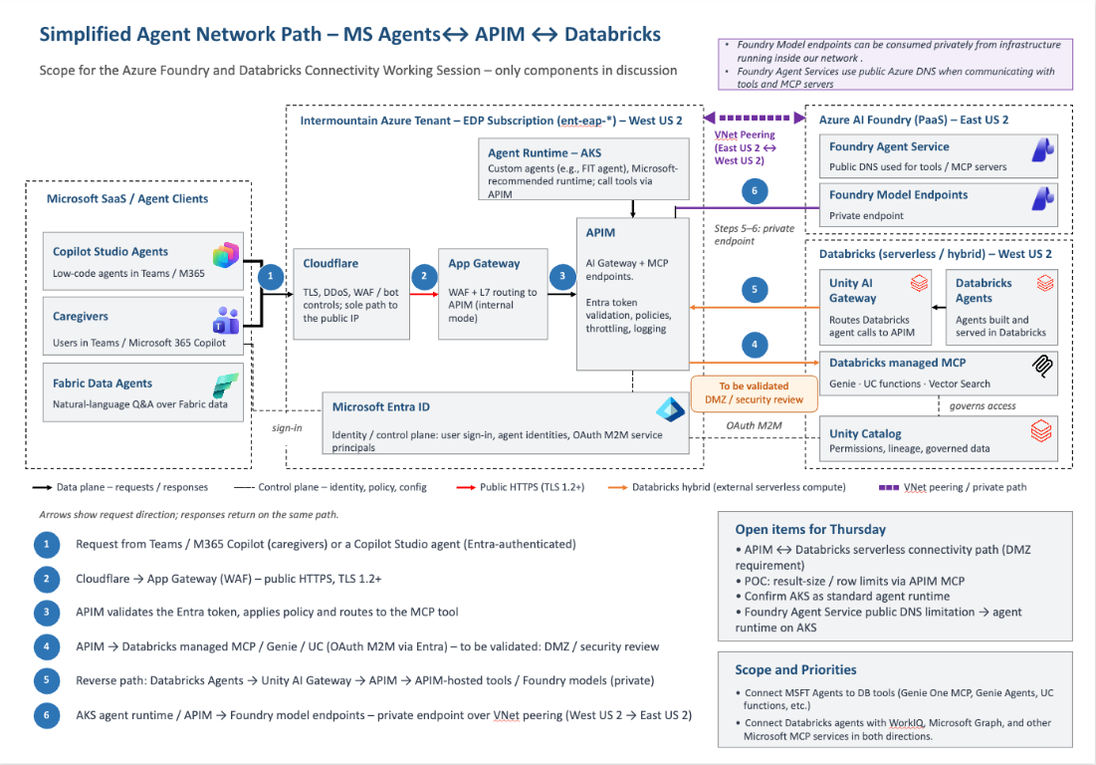
Image 1. Yun’s target architecture for IMH, boxes ① to ⑥
Yun | Box | What we show | Status
① | Teams / M365 Copilot / Copilot Studio (Entra sign-in) | Not built | Talk track
② | Cloudflare → App Gateway (WAF) | Not built (networking) | Talk track
Runtime | Agent runtime: AKS | Container Apps job job-imh-uc-agent with its own managed identity (step 10) | Stand-in
Runtime | Foundry Agent Service | Agents C and H (steps 6–7) | Live
③ | APIM validates the Entra token, applies policy, routes to the MCP tool | /uc-entra (token + allowed-app list, 401 otherwise); /uc and /uc-limited (key + limits) | Live (interim audience)
④ | APIM → Databricks managed MCP / UC, OAuth M2M via Entra | APIM signs in as umi-imh-uc-agent, a service principal in imh_analyst | Identity live; private network not built
UC | Unity Catalog governs access | Row filter + masks on imh_demo.clinical.patients | Live
⑤ | Databricks → Unity AI Gateway → APIM → Foundry models | Endpoint imh-foundry-gpt41-via-apim → APIM /aoai → gpt-4.1 (step 11) | Live
⑥ | AKS / APIM → Foundry models over private endpoint | /aoai over the public network | Public here
Open item | APIM ↔ Databricks serverless connectivity (DMZ) | Identity proven; network not built (Private Link one way, NCC the other) | Talk track
Open item | Result-size / row limits via APIM MCP | /uc-limited (step 7) | Live
Open item | AKS as the standard runtime | Same client in Container Apps; on AKS only the sign-in changes (workload identity) | Stand-in
Open item | Foundry public DNS limitation → runtime on AKS | Both runtimes call the same governed APIM tool | Live

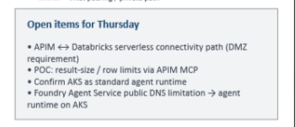
Image 2. Yun’s open items

Where the two priorities land
- Priority 1, Microsoft agents → Databricks tools: the middle path, Runtime → ③ → ④ → Unity Catalog. Steps 3–10.
- Priority 2, Databricks agents ↔ Microsoft services: ⑤ (Databricks → APIM → Foundry model, step 11) and Genie One → Microsoft 365 (step 12). The entry at ①, Copilot Studio or Teams calling Databricks, is not built.
- What to say about ⑥ and the open items: identity and policy are proven; the private network is the IMH build (Private Link from APIM to Databricks, NCC from Databricks serverless back to APIM).

4. Option 2: the slide and what runs
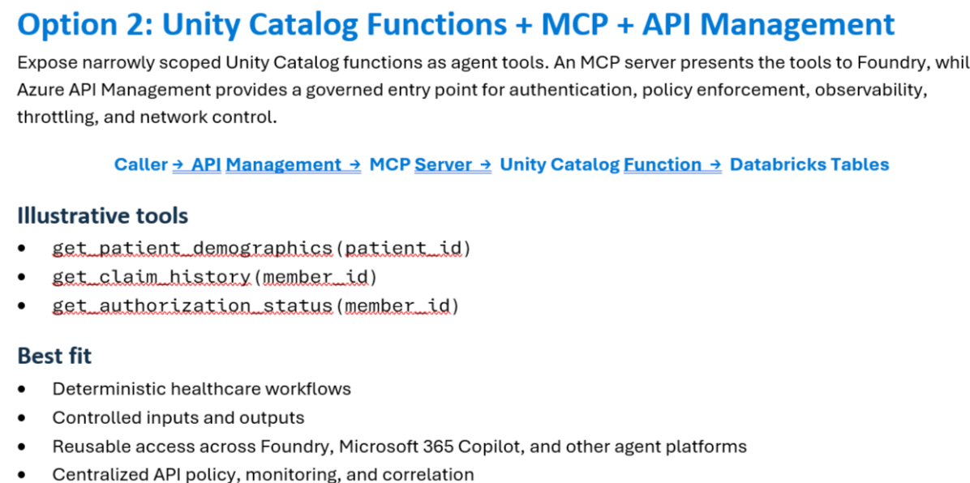
Image 3. IMH’s Option 2 slide: Azure agent → APIM → MCP server → UC function → Databricks tables
On the slide | What runs in the demo
Azure Agent | Foundry agents C (imh-uc-apim-umi-agent v6) and H (imh-uc-limited-agent v3); the Container Apps job job-imh-uc-agent as the AKS stand-in
APIM | apim-imh-uc-66zpmtcbvhe7w, routes /uc, /uc-limited and /uc-entra (plus /aoai for the reverse direction)
MCP Server | Databricks managed MCP server at /api/2.0/mcp/functions/imh_demo/clinical
UC Function | imh_demo.clinical.get_patients(fac) and get_patients_limited(fac, max_rows). The slide’s examples were get_patient_demographics, get_claim_history and get_authorization_status
Databricks Tables | imh_demo.clinical.patients: 12 synthetic rows with a row filter and two column masks

Why Option 2 fits (the slide’s “best fit” list)
- Deterministic workflows: the agent runs queries we wrote and only fills in parameters.
- Controlled inputs and outputs: no free-form SQL; APIM caps rows and size.
- Reuse across platforms: Foundry, M365 Copilot and others call the same MCP URL on APIM.
- Central API policy and monitoring: APIM policies and logs, plus Databricks Query History.
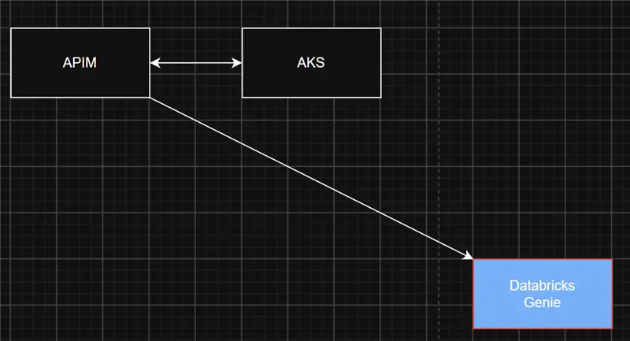
Image 4. IMH’s original sketch: APIM, AKS and Genie
NOTE Genie through APIM (segment G) and per-user Genie One from Foundry (segment K) both worked, but were removed from Foundry on Oct 14 to keep the demo to Option 2. Genie answers open questions; UC functions fit governed, repeatable workflows. Both can sit behind the same APIM.

5. End-to-end workflow, hop by hop
Each table follows one request from start to finish. The right column says where you can see that hop with your own eyes.

5.1 Segment C: Foundry agent → APIM → UC function (Priority 1)
# | What happens | Where to see it
1 | You ask agent C: “Show me patients at SLC.” | Foundry playground
2 | gpt-4.1 picks the only allowed tool, imh_demo__clinical__get_patients, with {"fac":"SLC"} | Foundry tool-call details
3 | Foundry calls https://apim-imh-uc-66zpmtcbvhe7w.azure-api.net/uc/mcp with the APIM key from project connection uc-fn-via-apim-umi | Foundry → Tools
4 | APIM checks the key, applies the rate limit and deletes the key header so it never reaches Databricks | APIM policy (Appendix C.1)
5 | APIM gets an Entra token for Databricks as umi-imh-uc-agent and rewrites the path to /api/2.0/mcp/functions/imh_demo/clinical | APIM policy
6 | The Databricks managed MCP server runs get_patients(fac => "SLC") on serverless compute as that service principal | Query History
7 | Unity Catalog applies fac_filter, mask_name and mask_ssn for group imh_analyst | Table → Overview
8 | 4 rows come back: names REDACTED, SSN ***-**-1001 to ***-**-1004 | Foundry answer; APIM log

5.2 Segment H: the same path with guardrails
- Agent H calls /uc-limited/mcp with its own APIM key (subscription imh-uc-limited-client).
- Inbound: 3 tool calls a minute (only tools/call counts) and 200 requests a day per subscription.
- Outbound: if a tool result has more than 5 rows or is larger than 20,000 bytes, APIM replaces it with an MCP error and adds header x-imh-gateway-block.
- Unity Catalog still decides rows and columns. APIM only limits volume (“the blast radius”).

5.3 Segment I: custom runtime with an Entra token (AKS stand-in)
# | What happens | Where to see it
1 | Container Apps job job-imh-uc-agent starts (manual trigger) | Job → Execution history
2 | The Python client gets an Entra token as umi-imh-uc-runtime. No key in the container | Console logs: auth=mi
3 | APIM /uc-entra validates the token: BrakeKat tenant, audience, and app ID on the allow-list. Anyone else gets 401 | APIM policy (Appendix C.3)
4 | APIM calls Databricks as umi-imh-uc-agent, exactly as in C | Query History
5 | tools/list returns 2 tools; tools/call returns 4 SLC rows, masked | Console logs (section 7.4)

On AKS only the sign-in changes: workload identity instead of the Container Apps managed identity. Same code, same APIM API.

5.4 Segment J: Databricks → APIM → Foundry model (Priority 2, Yun ⑤)
# | What happens | Where to see it
1 | The SQL editor on adb-demo-wh runs ai_query('imh-foundry-gpt41-via-apim', …) | SQL editor
2 | Serving endpoint imh-foundry-gpt41-via-apim (external model with AI Gateway: usage tracking, 60 calls a minute) reads the APIM key from secret scope imh-apim | Serving → endpoint
3 | APIM /aoai checks the key (subscription databricks-ai-gateway) and applies llm-token-limit: 20,000 tokens a minute | APIM policy (Appendix C.4)
4 | APIM signs in to Foundry with its managed identity and forwards to gpt-4.1 on aif-wu3 | APIM log
5 | The answer comes back as a column in the SQL result | SQL editor

5.5 Genie One → Microsoft 365 (Priority 2, screenshots)
- Genie One, Databricks’ own agent, answered “patients per facility” from Unity Catalog as jay.
- Through Databricks’ built-in Microsoft 365 connector (Jay signed in on Oct 13), it drafted an Outlook email with the summary (images 17–19).
- No app registration and no code. Work IQ is the next step: it needs Copilot licensing, and cyber has to clear PHI leaving the Azure boundary.

6. What was built, and what changed

6.1 Azure: subscription Azure-brakekat, resource group rg-ai, West US 3
Resource | Name | Type | Role in the demo
API Management | apim-imh-uc-66zpmtcbvhe7w | BasicV2 | Microsoft-side gateway: /uc, /uc-limited, /uc-entra, /aoai
Managed identity | umi-imh-uc-agent | User-assigned | APIM → Databricks (service principal in imh_analyst) and APIM → Foundry
Managed identity | umi-imh-uc-runtime | User-assigned | Job → APIM /uc-entra (Entra token, no key)
Container Apps job | job-imh-uc-agent | Manual trigger | AKS stand-in; APIM_AUTH=mi
Log Analytics | law-imh-uc-66zpmtcbvhe7w | Workspace | APIM gateway logs and job console logs
Foundry | aif-wu3 → project proj-imh-uc-demo | Foundry resource | gpt-4.1; agents C and H

APIM route | How it works
/uc | API “IMH UC functions MCP (via UMI)”. Caller: key, subscription foundry-imh-uc-agent  Policy: rate limit; managed identity to Databricks /api/2.0/mcp/functions/imh_demo/clinical
/uc-limited | API “IMH UC functions MCP - limited (rate, quota, size cap)”. Caller: key, subscription imh-uc-limited-client  Policy: 3 tool calls a minute, 200 a day; more than 5 rows or 20 KB becomes an MCP error with x-imh-gateway-block
/uc-entra | API “IMH UC functions MCP - Entra token (no key)”. Caller: Entra token; only the runtime’s app ID is allowed  Policy: 401 for anyone else; same backend
/aoai | API “Foundry models (via UMI)”. Caller: key, subscription databricks-ai-gateway  Policy: llm-token-limit 20,000 tokens a minute; managed identity to Foundry aif-wu3 gpt-4.1
/genie | API “IMH Genie space MCP (via UMI)”. Left in place from segment G; not shown on Oct 15

Foundry agent | Version | Tool connection → APIM route | Notes
imh-uc-apim-umi-agent (C) | v6 | uc-fn-via-apim-umi (APIM key) → /uc/mcp | Step 6. Allow-list imh_demo__clinical__get_patients; no approval prompt
imh-uc-limited-agent (H) | v3 | uc-limited-via-apim-umi-iac (APIM key) → /uc-limited/mcp | Step 7. Same allow-list; “leave fac out for all facilities”

Joey’s Foundry connections (CMS-Data-Agent-Connection, aif-rjb-eu2, CRM-AgentSkill, FabricPowerBIMCP): never touch.

6.2 Databricks: workspace adb-rjb-wu3, metastore metastore_azure_westus3
Object | Name | What it does
Catalog and schema | imh_demo.clinical | Holds the demo table and the two tool functions
Table | patients | 12 synthetic rows: SLC 4, OGDEN 3, PROVO 3, STGEORGE 2
Row filter | fac_filter | imh_phi_full and imh_analyst see every facility; imh_clinician_slc sees SLC only
Column mask | mask_name | Real (synthetic) names for imh_phi_full and imh_clinician_slc; REDACTED for everyone else
Column mask | mask_ssn | Full value for imh_phi_full; ***-**- plus the last 4 digits for everyone else
Table function | get_patients(fac) | MCP tool imh_demo__clinical__get_patients; leave fac out for all facilities
Table function | get_patients_limited(fac, max_rows) | Default 5 rows; Unity Catalog caps it at 10 whatever the agent asks
Group | imh_phi_full | jay: everything
Group | imh_clinician_slc | SLC only, names shown, SSN masked
Group | imh_analyst | All rows, names REDACTED, SSN masked. APIM’s identity is here
Service principal | umi-imh-uc-agent | APIM’s managed identity, added Oct 12 (images 8 and 9)
SQL warehouse | adb-demo-wh | Serverless; SQL editor, Genie and ai_query only. MCP calls don’t use it
Serving endpoint | imh-foundry-gpt41-via-apim | External model → APIM /aoai; AI Gateway usage tracking, 60 calls a minute
Secret scope | imh-apim | Holds the APIM key for the serving endpoint; the setup script put it there from memory, never on disk
Genie One + Microsoft 365 | Connector signed in as jay, Oct 13 | Priority 2 backup (step 12)

6.3 Oct 14 cleanup (Foundry only)
- Deleted agents A, B, G and K and their 3 OAuth tools (per-user Genie and UC paths, Genie through APIM, Genie One). Snapshot first: JAY DEMO v2\evidence\foundry-agents-before-cleanup.json.
- Fixed two agent behaviours seen in testing (sending fac:"", which returns 0 rows, and picking the wrong function): new versions C v6 and H v2 with a tool allow-list and the instruction to leave fac out for all facilities. H v3 (about 3:40 PM) is the same as v2 but references its connection by name, so the Foundry UI shows the tool.
- Databricks objects and APIM untouched. Items named hls-* belong to another demo and were left alone.
- Re-verified C, H, D, I and J live on Oct 14, 2:05–2:45 PM ET (section 7.1).
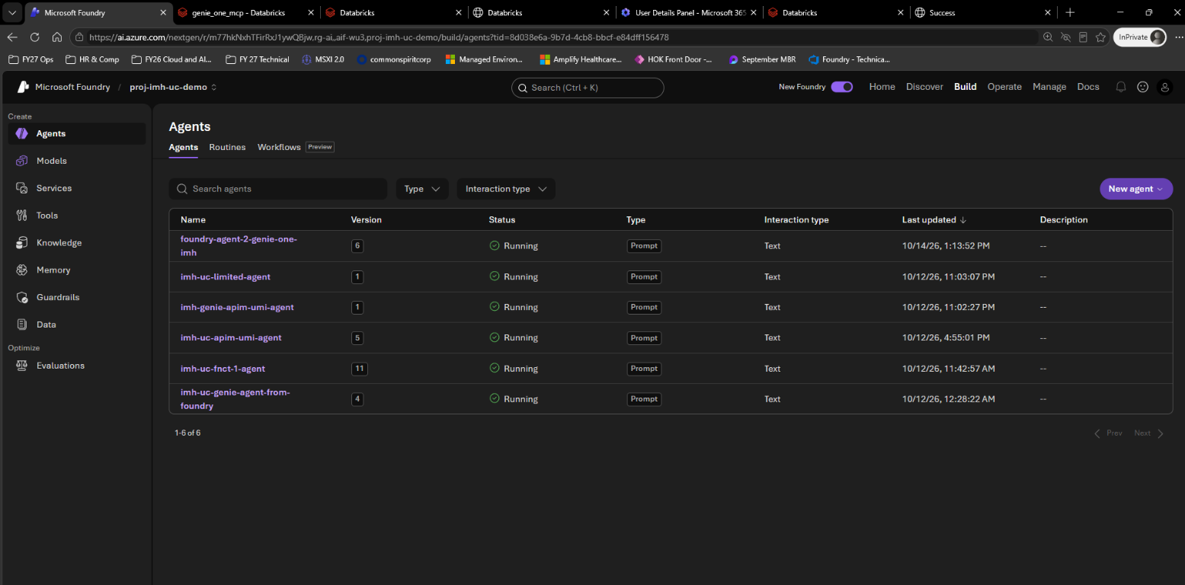
Image 7. Foundry agents before the Oct 14 cleanup

6.4 Databricks identity setup (Oct 12)
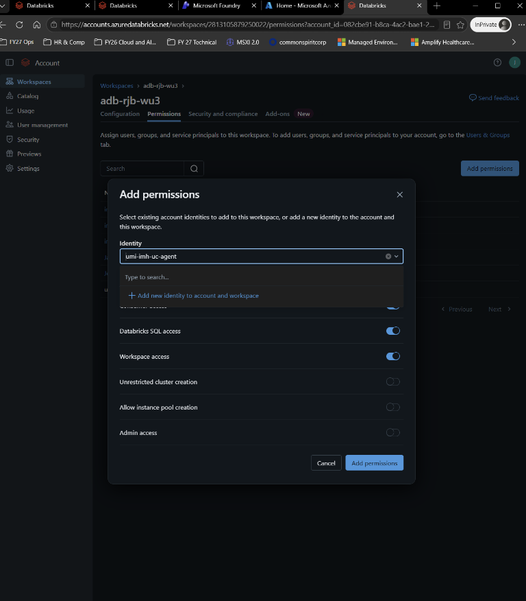
Image 8. APIM’s managed identity umi-imh-uc-agent added to the workspace as a service principal
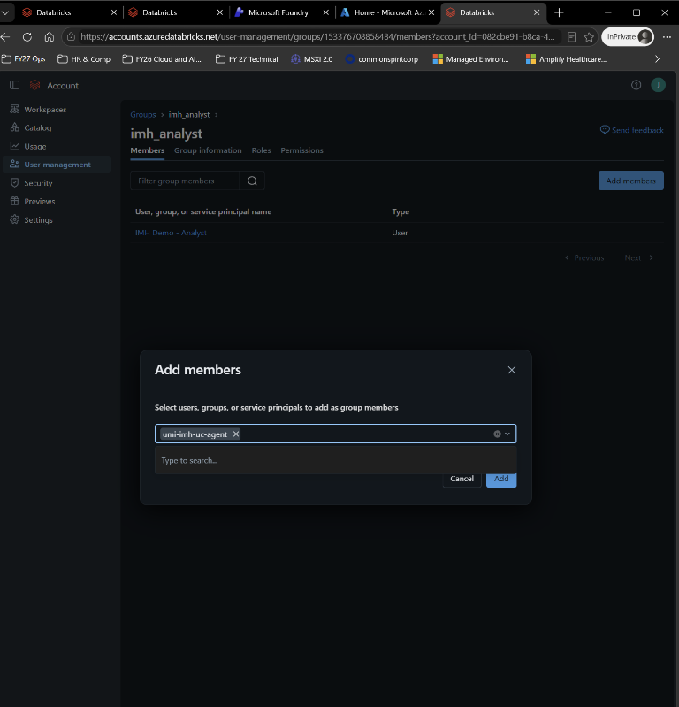
Image 9. The same identity added to group imh_analyst

6.5 Not ours: leave alone
- Two “HLS imaging” APIs in APIM (/hls-genie, /hls-uc) that point at another workspace.
- Container Apps jobs job-hls-genie-mcp-demo and job-hls-uc-mcp-demo in rg-ai (created Oct 13).
- Joey’s Foundry connections listed in 6.1.

6.6 After Oct 15
- Remove the Databricks app connections left from the per-user segments: foundry-genie-imh-uc and foundry-agent-genie-one-mcp-imh.
- Rotate the APIM subscription keys and the BrakeKat sign-in that was shared by text.
- Move the plaintext credentials in JAY DEMO v2\resources\ into a vault and delete them from the file.
- Run terraform validate on infra\uc-agent-gateway\.

7. Proof: what we saw

7.1 Re-verification, Oct 14, 2:05–2:45 PM ET
Segment | Test | Result | Pass
Script | /uc/mcp: tools/list, then SLC | Only get_patients and get_patients_limited are tools (filter and mask functions aren’t); 4 SLC rows, masked, ~22 s cold | Yes
C | Agent C v6: “Show me patients at SLC.” then “Show me all patients.” | get_patients {"fac":"SLC"} 4 rows (~7 s); get_patients {} 12 rows across 4 facilities; all masked | Yes
H | Agent H v2 (v3 re-tested about 3:40 PM): “Show me all patients across every facility.” | Blocked: 12 rows is over the 5-row limit. Then “SLC” returns 4 rows | Yes
D | Query History + APIM logs | SQL ran as umi-imh-uc-agent on serverless compute; APIM logged every call, blocked ones as 200 | Yes
I | Job job-imh-uc-agent, then Jay’s own token | Job: Entra token accepted on /uc-entra, 4 SLC rows, masked, 39 s. Jay’s Azure CLI token: 401 | Yes
J | ai_query and get_patients_limited(NULL, 50) as jay | Model answered through APIM; 10 rows (Unity Catalog’s cap) | Yes

7.2 What the analyst identity sees (agents C and H, job I)
patient_id | name | ssn | facility | diagnosis
P001 | REDACTED | ***-**-1001 | SLC | Type 2 diabetes
P002 | REDACTED | ***-**-1002 | SLC | Hypertension
P003 | REDACTED | ***-**-1003 | SLC | Congestive heart failure
P004 | REDACTED | ***-**-1004 | SLC | COPD

“Show me all patients” adds the other facilities, masked the same way:
Facility | Patients | SSN ends | Diagnoses
OGDEN | P005–P007 | 2005–2007 | Asthma; CKD stage 3; Atrial fibrillation
PROVO | P008–P010 | 3008–3010 | Community-acquired pneumonia; Major depressive disorder; Osteoarthritis of knee
STGEORGE | P011–P012 | 4011–4012 | Migraine; Hyperlipidemia

NOTE All values are synthetic. The live table was seeded during setup with its own synthetic rows, so the seed rows in the IaC (Appendix B) differ from these. The rules are the same.

7.3 Agent H: the gateway block
Blocked by gateway policy: the result has 12 rows (limit 5) or is larger than 20000 bytes.
Ask a narrower question, for example one facility.

- Response header: x-imh-gateway-block: row-limit 12>5.
- Foundry’s REST API reports it as HTTP 400 tool_user_error. APIM logs the call as 200, because the block is an MCP error inside a normal response.
- “OK, just SLC then.” returns the 4 SLC rows. A 4th tool call inside one minute gets 429 “Rate limit is exceeded”.
- Why the fix mattered: before Oct 14, H v1 sent fac: "" for “all facilities”. That returns 0 rows, so the cap never fired. H v2 leaves fac out. H v3 keeps that and references its connection by name, so the Foundry UI shows the tool.

7.4 Segment I: the job’s console log (Oct 14, 18:11:08 UTC, 39 s)
Execution job-imh-uc-agent-597gxc7-hhjsk. Key lines, with the JSON wrapped for reading:
# url=…/uc-entra/mcp auth=mi
initialize: HTTP 200 correlation c129cc9d-5b19-488e-81b1-e47bd124a587
notifications/initialized: HTTP 200 correlation 37ce31d0-2910-4f6c-bd71-b45a425bb2db
tools/list: HTTP 200 correlation 3d1570e8-cbd8-45f3-a0e3-18963e108173
tools: ['imh_demo__clinical__get_patients', 'imh_demo__clinical__get_patients_limited']
tools/call: HTTP 200 correlation 366baa32-4d63-43fd-b323-44d03911d6ea
{"columns": ["patient_id", "name", "ssn", "facility", "diagnosis"],
"rows": [["P001", "REDACTED", "***-**-1001", "SLC", "Type 2 diabetes"],
["P002", "REDACTED", "***-**-1002", "SLC", "Hypertension"],
["P003", "REDACTED", "***-**-1003", "SLC", "Congestive heart failure"],
["P004", "REDACTED", "***-**-1004", "SLC", "COPD"]]}

The 401 check: Jay’s own Azure CLI token on the same URL is refused with HTTP 401 “A valid Entra token for the UC agent gateway is required.”, because his app isn’t on the allow-list. Command in Appendix D.

7.5 Segment J: SQL run on adb-demo-wh as jay
SELECT ai_query('imh-foundry-gpt41-via-apim',
'In one sentence, what does Unity Catalog govern?') AS answer; -- one-sentence answer

SELECT count(*) AS rows_returned
FROM imh_demo.clinical.get_patients_limited(NULL, 50); -- 10

SELECT current_user(); -- jay@brakekat.com

- The second query asked for 50 rows and got 10: Unity Catalog’s own cap, on top of APIM’s.
- Image 15 shows the setup script’s checks: default 5 rows, capped 10 rows, endpoint READY, DATABRICKS-SIDE-COMPLETE.

7.6 Segment D: where each call is recorded
Record | What it shows
Databricks Query History | SELECT * FROM `imh_demo`.`clinical`.`get_patients`(fac => "SLC")  User umi-imh-uc-agent; Source “Spark Connect API”; Compute “Serverless compute for Notebooks”
APIM gateway logs | APIs imh-uc-functions-mcp and imh-uc-functions-mcp-limited: POST 200 (MCP call), POST 202 (MCP notification), GET 405 (stream request declined, harmless), with subscription and CorrelationId
Foundry | The tool call’s name and arguments in the run details
Job console logs | Each MCP step with its HTTP status and correlation ID (7.4)

7.7 Screenshots from the build
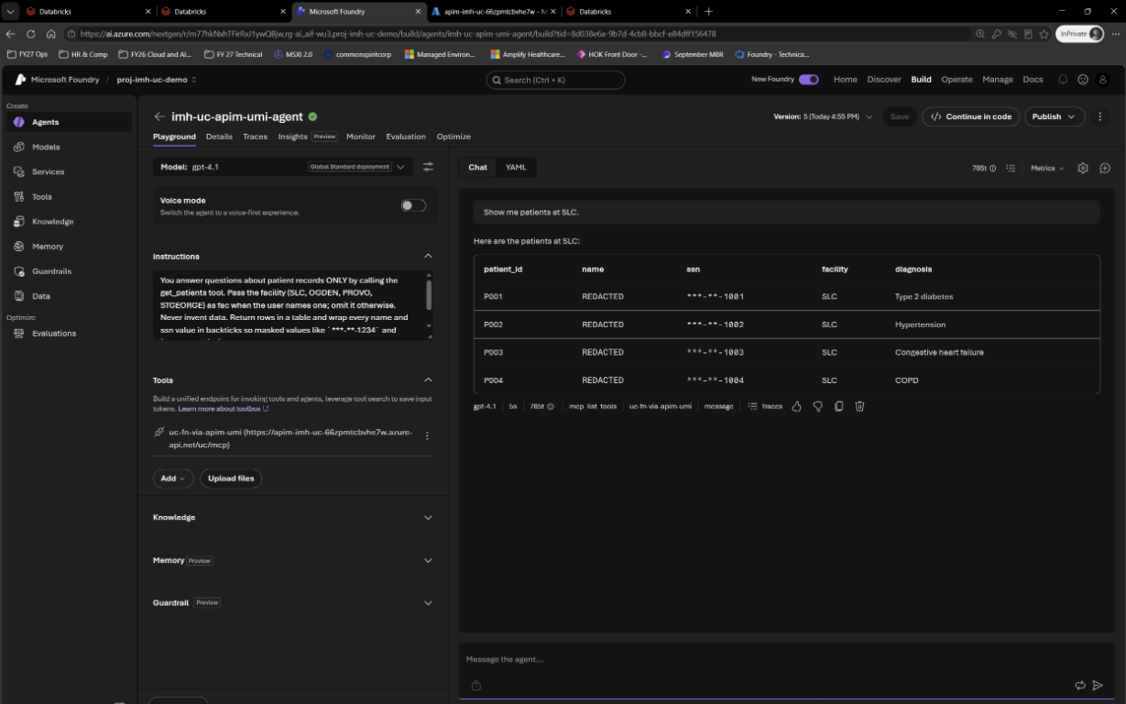
Image 10. Segment C: agent C answers for SLC with names and SSNs masked
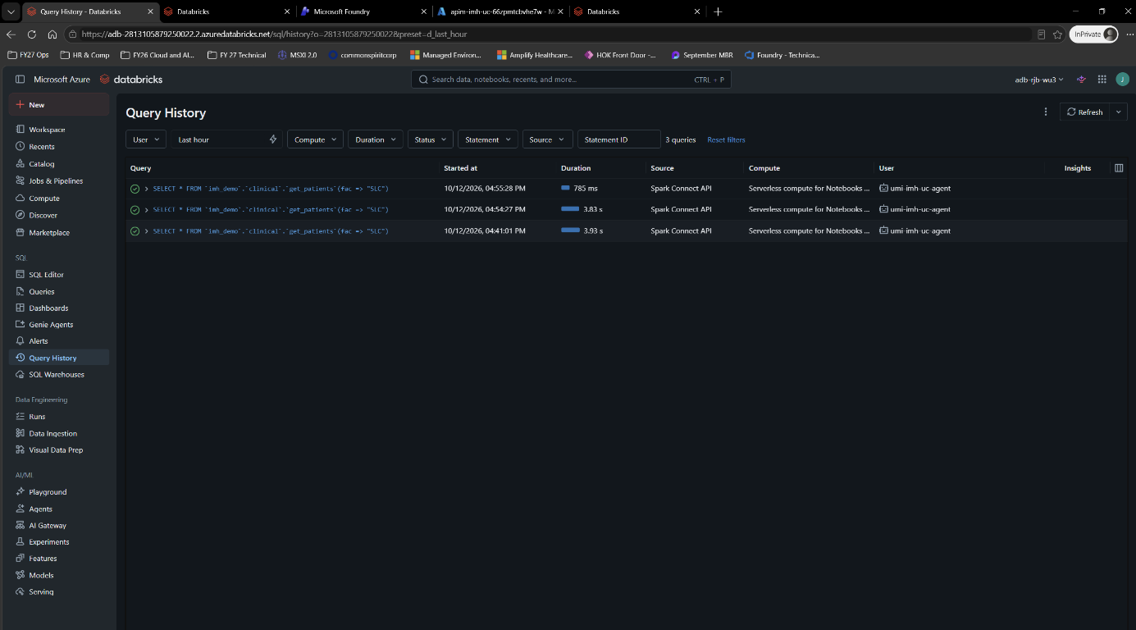
Image 11. Segment D: Query History shows the SQL ran as umi-imh-uc-agent
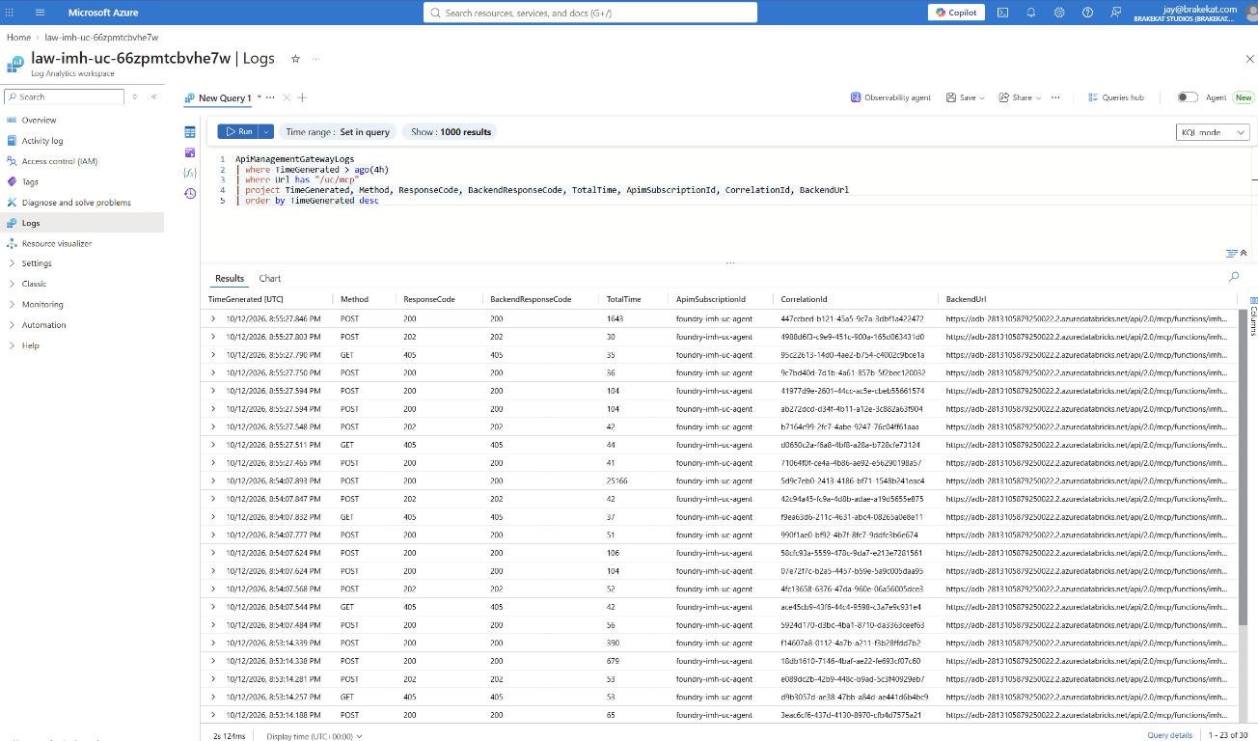
Image 12. Segment D: APIM gateway logs in Log Analytics
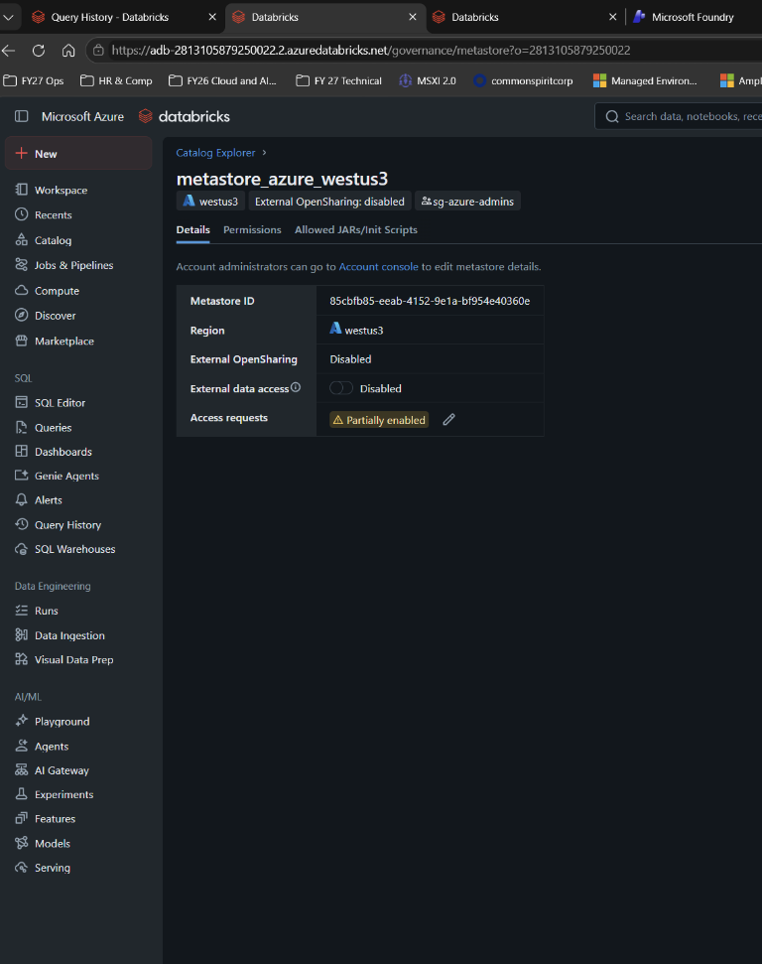
Image 13. Segment E: External Data Access turned off on the metastore (Oct 12)
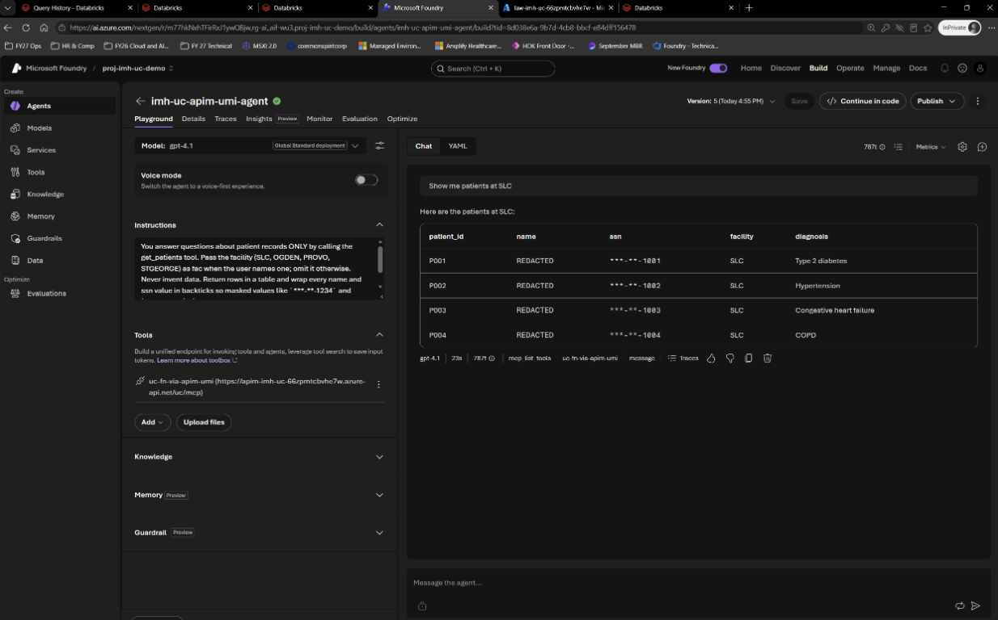
Image 14. Segment E: the agent still works with External Data Access off
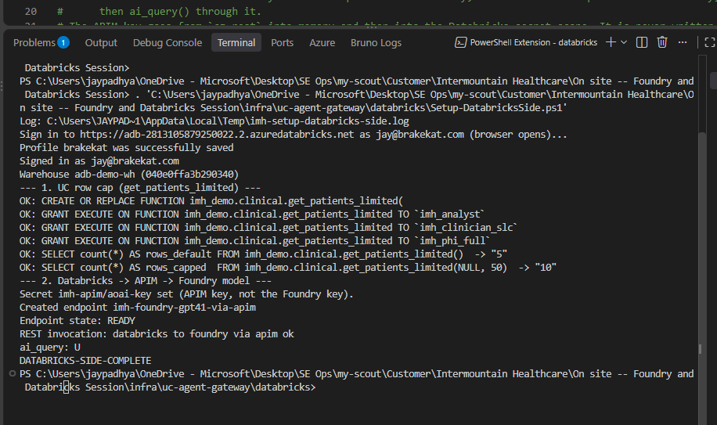
Image 15. Segment J: Databricks side complete (row cap, endpoint READY)
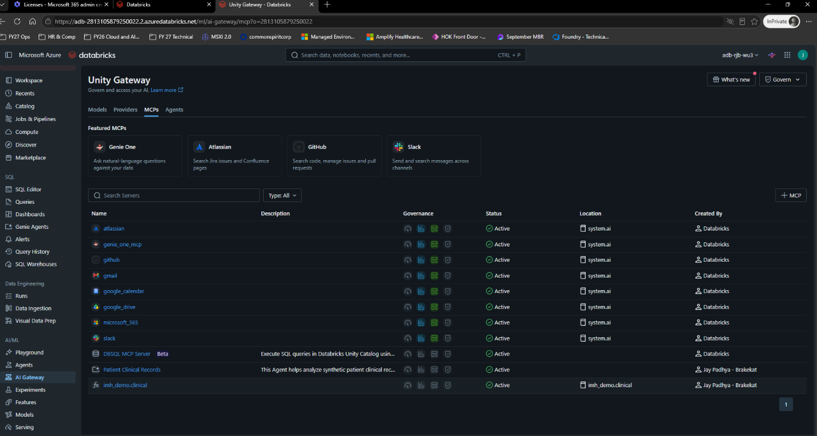
Image 16. Unity Gateway in the BrakeKat workspace: the MCP services list (Oct 13)
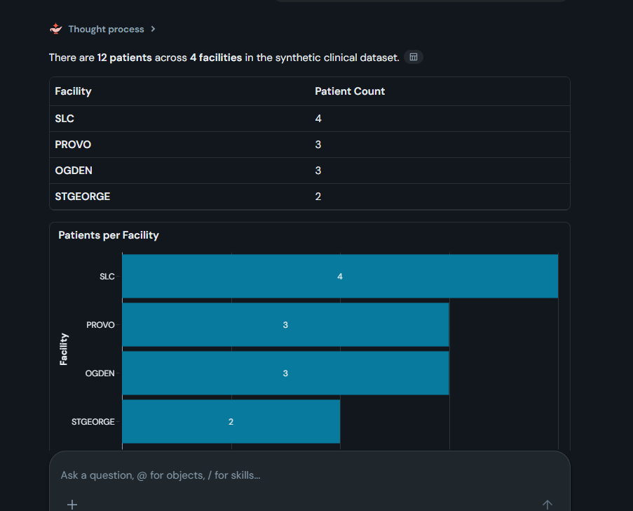
Image 17. Priority 2: Genie One answers “patients per facility” from Unity Catalog
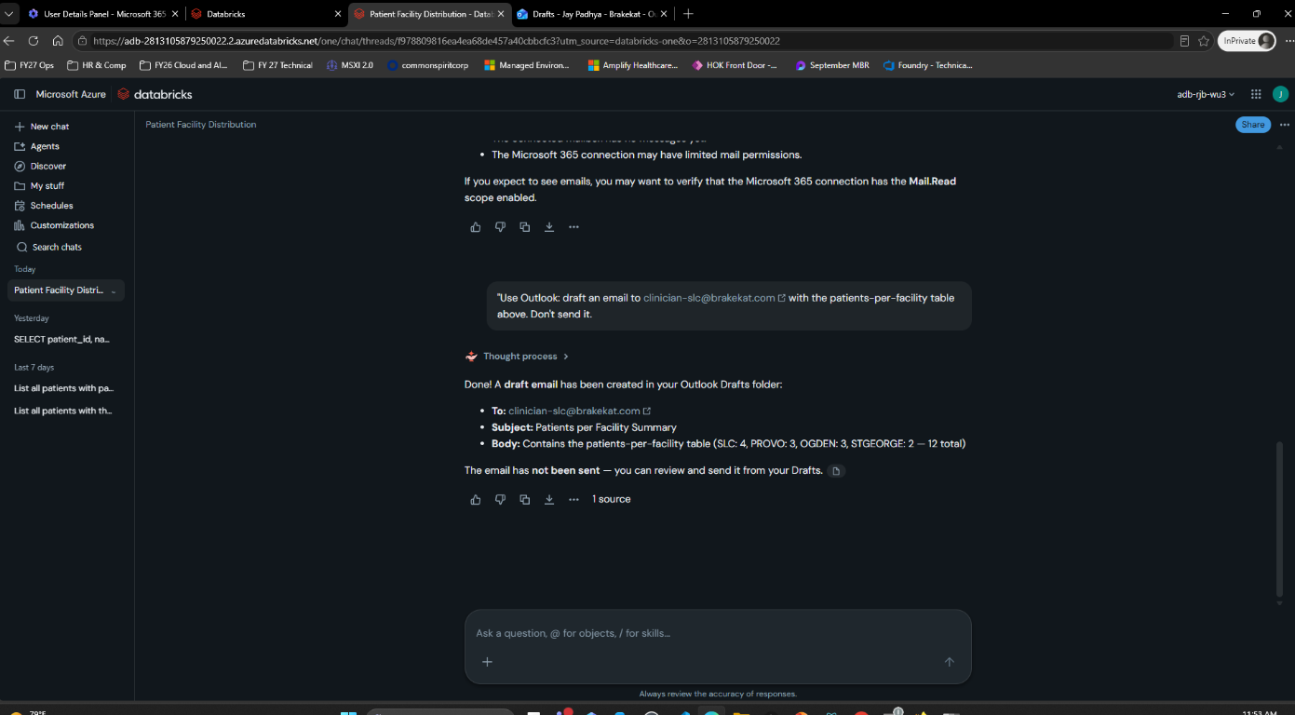
Image 18. Priority 2: Genie One drafts an email through the Microsoft 365 connector
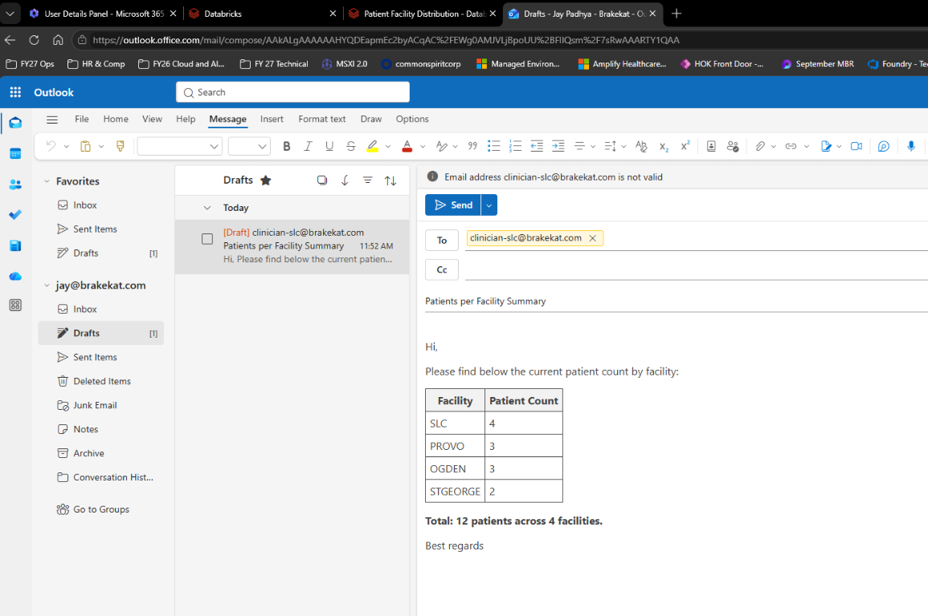
Image 19. Priority 2: the draft in Outlook

7.8 Evidence from the dry run
No dry-run screenshots yet. During the dry run, save PNGs as JAY DEMO v2\images\evidence\NN-<step>-<what>.png and rebuild this document (Appendix D).

8. Run of show

The day (Mark’s final agenda, Oct 13)
Time | Block | Jay
8:30 | Intros + infrastructure review (Mark, Bryan, Yun, Chris G.) | Not there yet (lands ~10:15)
9:15 | Scope, target resources, success criteria (Mark, Bryan)
10:00 | Hands-on design, setup, troubleshooting (breakouts) | Warm-ups from the car at ~10:45 (8.1)
11:00–12:00 | Presentation and demo of Microsoft/Databricks connections (Jay, Joey) | Joey opens with the Databricks side (~10 min), then steps 1–13 (~45 min)
12:00 | Lunch
1:00 | Reconnect + status (Mark, Bryan)
1:15–3:00 | Continued hands-on design, setup, validation | IMH sandbox (section 12)
3:00–3:30 | Foundry end-to-end (Jay); Fabric (Joey) | Section 8.4
3:30 | Tasks, outputs, follow-ups (for example a demo for Brian, Andy and Shawn) | Write down follow-ups

8.1 Pre-flight
Sign in (Edge only): Foundry and Databricks as jay@brakekat.com. Azure portal in the BrakeKat directory with the account that owns rg-ai. Option 2 needs no per-user browsers.
Tabs, in this order (links in Appendix A):
- Image 1 (Yun’s diagram) and image 3 (Option 2 slide)
- Databricks table imh_demo.clinical.patients
- Databricks → Settings → Identity and access → Groups → imh_analyst
- Azure portal → apim-imh-uc-66zpmtcbvhe7w → APIs
- Agent C (Foundry deep link)
- Agent H (same link with imh-uc-limited-agent)
- Databricks Query History, last hour
- Log Analytics law-imh-uc-66zpmtcbvhe7w → Logs, with the KQL from Appendix D pasted
- Azure portal → Container Apps job job-imh-uc-agent
- Databricks Serving → imh-foundry-gpt41-via-apim, plus the SQL editor on adb-demo-wh with the two step 11 queries
- Images 17–19 (Priority 2)
- This document (fallback)
Warm-ups (10 minutes before):
- Agent C: “Show me patients at SLC.” This wakes serverless compute (~20 s cold, ~7 s warm).
- SQL Warehouses → adb-demo-wh → Start (needed only for step 11).
- Start the job about 3 minutes before step 10 (its logs take 1–5 minutes to appear).
- Don’t use agent H in the minute before the demo (3 tool calls a minute).
- In each agent, check the version picker shows C v6 and H v3 (refresh first).
On the day: you arrive at 11:00. Do the warm-ups from the car at ~10:45 (phone hotspot), or ask Joey to run agent C once and start adb-demo-wh. Joey opens with the Databricks side, so steps 3–4 may already be covered.

8.2 The steps (11:00–12:00 block, ~45 minutes)
Each step: Open → Ask or Expect → Say → If it fails. Read the blue boxes out loud.

Step 1. Frame it on Yun’s diagram (3 min) · Yun: all
Open: image 1 (Yun’s diagram).
SAY “Your two priorities are Microsoft agents using Databricks tools, and Databricks agents using Microsoft services. On Yun’s diagram I’ll walk the middle path: an agent calls APIM, APIM calls Databricks as a managed identity, and Unity Catalog decides what comes back. That’s ③ and ④. Then ⑤: Databricks calling a Foundry model through the same APIM.”

Check yourself: which component decides which rows come back? Unity Catalog.

Step 2. The Option 2 slide (2 min)
Open: image 3.
SAY “Option 2 is exactly what’s running: Azure agent, APIM, MCP server, UC function, tables. The tools are Unity Catalog functions, so the agent can only run queries we wrote and fill in parameters. No free-form SQL. Your slide’s examples were get_patient_demographics or get_claim_history; ours is get_patients by facility.”

Step 3. The rules live in Unity Catalog (4 min) · Yun: “Unity Catalog governs access”
Open: tab 2 (table patients) → Overview shows the row filter and column masks; then the schema → Functions.
Expect: row filter fac_filter; masks on name and ssn; functions get_patients and get_patients_limited.
SAY “This is synthetic data: 12 patients in 4 facilities. Unity Catalog has three rules on this table: a row filter by facility, and masks on name and SSN. They’re checked for whoever runs the query, every time. The agent’s tool is this function, get_patients. It runs inside Databricks, so the rules always apply.”

If Joey already showed it: say “As Joey showed, the rules sit on the table,” then go to step 4.

Step 4. Who Databricks thinks is calling (2 min) · Yun ④
Open: tab 3 (imh_analyst → Members).
Expect: umi-imh-uc-agent.
SAY “APIM signs in to Databricks as this managed identity: an Entra identity with no password or secret. In Databricks it’s a service principal in the analyst group, so every call through APIM gets analyst rules: all facilities, names redacted, SSNs masked. That’s Yun’s ④, machine-to-machine sign-in through Entra.”

Step 5. The gateway policy (3 min) · Yun ③ → ④
Open: tab 4 → “IMH UC functions MCP (via UMI)” → All operations → Inbound processing → </>.
Expect: rate-limit-by-key, two set-header … delete, rewrite-uri, authentication-managed-identity. Full text in Appendix C.1.
SAY “This is the Microsoft-side gate. It rate-limits each caller, strips the caller’s key so it never reaches Databricks, forwards to the Databricks MCP server for imh_demo.clinical, and gets an Entra token for Databricks as the managed identity. Nothing secret is stored in the policy.”

Step 6. Segment C live: Foundry agent → APIM → UC function (6 min) · Foundry box → ③ → ④ → UC
Open: tab 5 (agent C, v6).
Ask: “Show me patients at SLC.”
Expect: tool call imh_demo__clinical__get_patients with {"fac":"SLC"}; 4 rows P001–P004, names REDACTED, SSN ***-**-1001 to ***-**-1004; ~7 s warm, ~20 s cold.
Ask: “Show me all patients.”
Expect: get_patients with {}; 12 rows across SLC, OGDEN, PROVO and STGEORGE, all masked.
SAY “The agent chose the get_patients tool and filled in the facility. The call went to APIM, APIM called Databricks as the managed identity, and Unity Catalog applied the analyst rules, which is why names say REDACTED. Nobody signed in to Databricks, and the agent never held a Databricks credential.”

If it fails: slow → cold serverless; wait 30 s and ask again. Approval prompt → wrong version selected (pick v6) or click Approve. 0 rows → check the tool-call arguments, run the script check (Appendix D) and show image 10 (section 7.7).

Step 7. Segment H: gateway guardrails (5 min) · Open item: result-size and row limits
Open: tab 6 (agent H, v3).
Ask: “Show me all patients across every facility.”
Expect: blocked. The gateway’s text: “Blocked by gateway policy: the result has 12 rows (limit 5) or is larger than 20000 bytes. Ask a narrower question, for example one facility.” Foundry shows it as a tool error, or the agent rewords it and suggests one facility. Both are a pass.
Ask: “OK, just SLC then.” → 4 rows.
SAY “Same identity, same data, different APIM route. This one has guardrails: more than 5 rows or 20 KB comes back as an error, 3 tool calls a minute, 200 a day. APIM doesn’t know your PHI rules and shouldn’t; Unity Catalog still decides the rows. APIM limits the blast radius. That’s your open item on result-size limits.”

Add (the layers):
SAY “In testing, an agent picked the wrong function, so the agent now has an allow-list too. The allow-list picks the tool, the function fixes the query, APIM limits volume, and Unity Catalog decides rows and columns.”

Optional 429: ask 4 SLC questions inside a minute; the 4th gets “Rate limit is exceeded”.
SAY “That’s the rate limit doing its job.”

If it isn’t blocked: the agent sent a facility. Ask again: “All facilities, no filter.” Or run the script check (Appendix D).

Step 8. Segment D: the audit trail (5 min)
Open: tab 7 (Query History, last hour). Filter User = umi-imh-uc-agent if the list is busy.
Expect: SELECT * FROM `imh_demo`.`clinical`.`get_patients`(fac => "SLC"), User umi-imh-uc-agent, Source “Spark Connect API”, Compute “Serverless compute for Notebooks” (not adb-demo-wh).
Open: tab 8 (Log Analytics) → run the KQL (Appendix D).
Expect: rows for imh-uc-functions-mcp and imh-uc-functions-mcp-limited: POST 200, POST 202, GET 405, with ApimSubscriptionId and CorrelationId.
SAY “Both sides keep a record. Databricks shows the exact SQL the tool ran and that it ran as the agent identity. APIM shows which subscription called, the response and a correlation ID. A blocked result still logs 200 in APIM, because the block comes back as an MCP error inside a normal response.”

Concept: POST 202 = MCP notification. GET 405 = the client asks for a stream and Databricks declines (harmless).
If empty: APIM logs lag 2–5 minutes, so widen to ago(24h). Show images 11 and 12 (section 7.7).

Step 9. Segment E: no External Data Access (1 min) · Screenshots only
Open: images 13 and 14 (section 7.7).
SAY “External Data Access lets outside engines read Unity Catalog storage directly. We turned it off on October 12 and the agent still worked, because the function runs inside Databricks. Fabric mirroring is the path that needs it, and that’s out of scope.”

NOTE Never toggle External Data Access live. It’s Joey’s metastore.

Step 10. Segment I: custom runtime, Entra token, no key (4 min) · Yun ③ + AKS box
Open: tab 9 → Run now (about 3 minutes earlier) → Execution history → latest → Console logs.
Expect: # url=…/uc-entra/mcp auth=mi, initialize: HTTP 200, the two tool names, tools/call: HTTP 200, then 4 SLC rows, masked (section 7.4). The Oct 14 run took 39 s; logs appeared within about 2 minutes.
Optional: run the 401 check (Appendix D) and show the output.
SAY “This stands in for your AKS pod: a Python client with its own managed identity and no key in the container. APIM validates its Entra token: right tenant, right audience, and its app ID is on the allow-list. My own token gets a 401 because I’m not on the list. On AKS it’s the same code with workload identity.”

If the logs are empty: they lag 1–5 minutes; show the previous run or section 7.4.

Step 11. Segment J: Databricks → APIM → Foundry model (4 min) · Yun ⑤ (⑥ is public here) · Priority 2
Open: tab 10: Serving → imh-foundry-gpt41-via-apim (AI Gateway: usage tracking, 60 calls a minute), then the SQL editor on adb-demo-wh.
Run, one at a time:
SELECT ai_query('imh-foundry-gpt41-via-apim',
'In one sentence, what does Unity Catalog govern?') AS answer;

SELECT count(*) AS rows_returned
FROM imh_demo.clinical.get_patients_limited(NULL, 50);

Expect: a one-sentence answer (~18 s if the warehouse is starting), then 10.
NOTE Use count(*) in the room. As jay (imh_phi_full), the rows themselves show full synthetic names and SSN-like values.

SAY “Now the other direction, Yun’s ⑤: Databricks calling a Foundry model. The serving endpoint points at our APIM, not straight at Foundry. APIM applies a token limit and signs in to Foundry with a managed identity, and Databricks’ AI Gateway adds its own usage tracking and rate limit. And Unity Catalog can cap rows itself: I asked this function for 50 and got 10.”

If it fails: start adb-demo-wh and check the endpoint is READY; otherwise show image 15.

Step 12. Priority 2: a Databricks agent writes to Microsoft 365 (3 min) · Screenshots
Open: images 17, 18 and 19 (section 7.7).
SAY “Your second priority is Databricks agents working with Microsoft services. Databricks’ own agent, Genie One, answered from Unity Catalog and then drafted this Outlook email through Databricks’ built-in Microsoft 365 connector, signed in as me. No app registration, no code. Work IQ is next: it needs Copilot licensing, and cyber has to clear PHI leaving the Azure boundary. The reverse direction, Copilot Studio or Teams calling Databricks, is ① on Yun’s diagram and isn’t built.”

Step 13. Limitations and this afternoon (3 min)
SAY “Three things to be clear about. One: this is our demo tenant with synthetic data on public endpoints. The private network isn’t built: Private Link from APIM to Databricks, and NCC for serverless back to APIM. Two: on this path Databricks sees the agent’s identity, not the caregiver’s. That’s Yun’s design for ④; per-user sign-in works too, and we proved it separately. Three: we call Databricks’ legacy MCP endpoint. For a new build, point APIM at the Unity Gateway URL so both gateways apply. This afternoon in your sandbox we can stand up the same pattern: one UC function, APIM’s identity as a service principal, and one APIM API.”

8.3 After step 13: the questions most likely to come
Answers are in section 10. Be ready for these four first:
- Do we need External Data Access? (No.)
- Who decides what the agent sees? (Unity Catalog, always.)
- Does Databricks know which caregiver asked? (Not on this path; it sees the agent identity.)
- What’s the kill switch? (Disable the APIM subscription or remove the app from the allowed list.)

8.4 3:00–3:30: Foundry end-to-end (~20 minutes)

1. Foundry project tour (5 min)
Open: agents C and H → Tools: the MCP tool → its connection (APIM key); model gpt-4.1; the allow-list.
SAY “The agent is a prompt, a model and one tool. The tool is just an MCP URL on APIM and a key in a project connection, which you can swap for an Entra token.”

2. Policies side by side (8 min)
Open: in APIM, the inbound policy of /uc (key + managed identity), then /uc-limited (rate, quota, row and size cap: show the outbound rowCount > 5 block), then /uc-entra (validate-azure-ad-token with client-application-ids). Full text in Appendix C.
SAY “Three routes, one Databricks backend. The first checks a key and signs in to Databricks as the managed identity. The second adds rate, quota and a row and size cap on the way out. The third takes no key at all: only an Entra token from an app on its list. Your control plane picks the route for each agent.”

3. One call traced (5 min)
Open: a Foundry chat → APIM log (CorrelationId) → Databricks Query History (identity and SQL).
SAY “One question, three records that tell the same story: Foundry shows the tool call, APIM shows the caller and a correlation ID, and Databricks shows the exact SQL and the identity that ran it.”

4. Infrastructure as code (7 min)
Open: infra\uc-agent-gateway\.
- Bicep: deployed and tested in BrakeKat.
- Terraform (Azure + Databricks): written; terraform validate not run yet.
- databricks\Setup-DatabricksSide.ps1: ran Oct 13.
- foundry\create_agents.py: new --allowed-tools.
- clients\python_mcp_client.py: smoke tests.
SAY “Everything you saw is in this folder. IMH changes the parameters: tenant, workspace, catalog and schema, groups, and the gateway’s app ID.”

5. Sandbox results (5 min)
Show whatever the 1:15–3:00 hands-on produced (section 12).

9. If something breaks
Symptom | Fix | Fallback
First agent answer takes 20+ s | Serverless cold start. Talk through step 5 while it runs | —
Approval prompt in C or H | An old version is selected: pick C v6 or H v3, or click Approve | —
H’s Tools panel is empty | H v2 is selected (it references its connection by full ID, so the UI hides the tool); pick H v3 | Chat still works on v2; show the YAML tab
C returns 0 rows | Check the tool-call arguments: they should be {"fac":"SLC"} or {} | Image 10 + script check (Appendix D)
H returns rows for “all” | The agent sent a facility. Ask “All facilities, no filter.” | Script check with --args '{}'
429 on H | Rate limit (3 tool calls a minute). Wait 60 s and say “that’s the limit working” | —
Query History empty | Widen the time range; clear the Compute filter (MCP calls run on serverless, not adb-demo-wh) | Image 11
APIM logs empty | Ingestion lag 2–5 minutes; widen to ago(24h) | Image 12
Job logs empty | Lag 1–5 minutes; show the previous run | Section 7.4, or run the job commands in Appendix D
ai_query error | Start adb-demo-wh; check the endpoint is READY | Image 15
Foundry opens the wrong tenant | Use the deep link with ?tid=8d038e6a-9b7d-4cb8-bbcf-e84dff156478 (Appendix A) | —
Everything is down | Walk section 8 from this document | Screenshots in section 7.7

NOTE If a live step fails twice, show its screenshot and move on. The screenshots prove the same thing, and the room cares about the pattern, not the click.

Words for a failure in the room
SAY “That’s serverless waking up, which is a real thing you’ll see in production too. While it runs, here’s what it’s doing.”

SAY “Let me show you a recorded run instead; it’s the same call and the same rules.”

10. Questions and answers
Say each answer in under 20 seconds. The first four are the most likely.
Question | Answer
Do we need External Data Access? | No. The function runs inside Databricks. We proved it with External Data Access off. Fabric mirroring is the path that needs it
Who decides what the agent sees? | Unity Catalog, always. APIM controls who calls, how often and how much comes back, and logs it
Does Databricks know which caregiver asked? | Not on this path: it sees the agent identity (Yun ④, machine to machine). Per-user is the OAuth passthrough path, proven separately; it needs Foundry and Databricks in the same Entra tenant
Kill switch? | Disable the APIM subscription or remove the client from the allowed list (instant); remove the service principal from the group; disable the managed identity. Entra Agent ID / Agents 365 is the enterprise version (talk track)
Why APIM if Unity Catalog already governs? | One Microsoft-side gate for every agent platform (Foundry, AKS, Copilot Studio): Entra or key auth, rate limits, quotas, result caps, logs and a kill switch, without touching Databricks
What stops an agent pulling the whole table? | Four layers: agent allow-list, fixed UC function, APIM row and size cap and rate limit, Unity Catalog rules. Unity Catalog can also cap rows itself (get_patients_limited)
Where are the secrets? | None between APIM and Databricks (managed identity). Foundry → APIM uses an APIM key stored in the Foundry connection; the AKS path uses an Entra token, no key
Private networking? | Not built here. APIM → Databricks needs Private Link; serverless → APIM needs NCC. Foundry Agent Service resolves tools over public DNS, which is why Yun puts the runtime on AKS
Which Databricks MCP endpoint? | Today the legacy /api/2.0/mcp/functions/<catalog>/<schema>. New builds: Unity Gateway /ai-gateway/mcp-services/… for MCP grants, policies and tracing. The Genie One beta endpoint sunsets Oct 31, 2026; not used
What compute runs the tool? | Databricks serverless (first call ~20 s cold). IMH must allow serverless in the workspace
How do we audit one call? | APIM log (subscription, CorrelationId) + Query History (exact SQL, identity) + Foundry trace. Can feed Sentinel or system.access.audit
How do we add a tool? | Write a table function in the schema and grant EXECUTE. It shows up in tools/list; add it to the agent’s allow-list
Work IQ? | Needs Microsoft 365 Copilot licences or pay-as-you-go credits; data can leave the Azure compliance boundary, so cyber has to clear PHI
Can we deploy it as code? | Yes: infra/uc-agent-gateway (Bicep tested; Terraform written; Databricks setup script; agent script)
Is this IMH-ready? | The pattern is. IMH adds its tenant, Private Link and NCC, AKS workload identity, the gateway app registration api://imh-uc-gateway, and cyber sign-off for MCP on apim-ih-ent-eap-dev
Which IMH project is this for? | Not one project. Mark named Ventures as the clearest case for Microsoft agents using Databricks tools; others benefit from Microsoft MCP tools in Databricks agents
Does it fit what Brian’s team built? | Yes. Their control plane is APIM + AKS with managed identities and an Agents 365 kill switch. Option 2 adds one APIM API per UC schema and one service principal in Databricks

11. Not built, and BrakeKat vs IMH
Say these before anyone asks. Step 13 covers the first three.
- ① Copilot Studio / Teams → Databricks, and ② Cloudflare → App Gateway (WAF): talk track only.
- Private network: Private Link (APIM → Databricks), NCC (Databricks serverless → APIM), VNet peering, West US 2 + East US 2.
- AKS: a Container Apps job stands in, because the AKS provider isn’t registered in BrakeKat. On AKS it’s the same code with workload identity.
- Gateway app registration: the interim Entra audience is ARM (https://management.azure.com) plus the allowed-client list. IMH would use api://imh-uc-gateway.
- APIM → Unity Gateway MCP URL: untested. The legacy MCP endpoints are proven.
- Work IQ; Microsoft Learn MCP; a custom Databricks agent on the /aoai endpoint.
- terraform validate not run.
Item | BrakeKat demo | IMH
Tenant and data | Joey’s demo tenant, 12 synthetic rows | IMH tenant, real data
Runtime | Container Apps job | AKS + workload identity
Entra audience | ARM + allowed-app list | api://imh-uc-gateway
Network | Public | Private Link + APIM VNet integration
Front door | None | Cloudflare → App Gateway (WAF) → internal APIM
Regions | West US 3 | West US 2 + East US 2, peered
APIM → Databricks MCP | Working | apim-ih-ent-eap-dev has Databricks REST only; MCP is in cyber review (Yun, Oct 14)

Caveats to say up front
- One tenant here, by necessity. Foundry’s per-user passthrough needs the user in the Foundry project’s Entra tenant, so Foundry and Databricks both sit in BrakeKat. IMH would run both in its own tenant, which is the real single-tenant setup.
- Public network only. A fully private MCP path is still unproven and is a joint test for the onsite breakout.
- Agent identity, not caregiver identity. Option 2 runs as APIM’s managed identity (Yun ④). Per-user sign-in (segments A, B and K) was proven Oct 12–14 and removed from Foundry for the onsite; the evidence is in Jay DEMO\evidence\brakekat-uc-proof\README.md.
- Legacy MCP endpoint. APIM calls /api/2.0/mcp/functions/imh_demo/clinical, which bypasses Unity Gateway. For a new build, point APIM at the Unity Gateway URL so both gateways apply.

12. IMH sandbox: the 1:15–3:00 hands-on
Workspace: https://adb-7405605832508369.9.azuredatabricks.net (Peter Jones; group DPG_FOUNDRY_CONNECTION_TEST). Non-PHI data only.
SAY “Let’s stand up the same pattern in your sandbox: one UC function, APIM’s identity as a service principal, and one APIM API. Unity Catalog stays the only place the rules live.”

Checklist
- Managed MCP servers enabled (workspace Admin → Previews).
- Serverless compute allowed in the workspace (MCP tool calls run on it).
- A non-PHI table to point at.
- One UC table function on that table (pattern below).
- APIM’s managed identity added as a service principal, with USE CATALOG, USE SCHEMA, SELECT and EXECUTE.
- An APIM API → /api/2.0/mcp/functions/<catalog>/<schema> with the policy in Appendix C.1 (policy-mcp-key.xml).
- Test with infra\uc-agent-gateway\clients\python_mcp_client.py (Appendix D shows the calls).
NOTE apim-ih-ent-eap-dev has Databricks REST only; MCP on it is in cyber review (Yun, Oct 14). If it hasn’t cleared, do items 1–5, test the function in the SQL editor, and leave the APIM API as a follow-up.

Function and grants pattern
Same shape as get_patients (Appendix B). Replace each <...> placeholder. A service principal is named by its application (client) ID.
CREATE OR REPLACE FUNCTION <catalog>.<schema>.get_rows(
p_value STRING DEFAULT NULL COMMENT 'Filter value. NULL = all rows the caller may see.')
RETURNS TABLE (<col1> STRING, <col2> STRING)
COMMENT 'Rows visible to the caller under Unity Catalog rules.'
RETURN
SELECT <col1>, <col2>
FROM <catalog>.<schema>.<table>
WHERE p_value IS NULL OR <col1> = p_value;

GRANT USE CATALOG ON CATALOG <catalog> TO `<apim-identity-application-id>`;
GRANT USE SCHEMA ON SCHEMA <catalog>.<schema> TO `<apim-identity-application-id>`;
GRANT SELECT ON TABLE <catalog>.<schema>.<table> TO `<apim-identity-application-id>`;
GRANT EXECUTE ON FUNCTION <catalog>.<schema>.get_rows TO `<apim-identity-application-id>`;

What to write down for the 3:30 follow-ups
- What worked and what was blocked (network, preview, permissions, cyber review), with owners and dates for MCP on apim-ih-ent-eap-dev, Private Link + NCC, the gateway app registration and AKS workload identity.
- Whether Brian, Andy and Shawn want their own demo of this path.

13. How we got here: Oct 11–15
All times Eastern.
When | What happened
Oct 11, 10:21 PM | Foundry project proj-imh-uc-demo created in the BrakeKat tenant. Overnight setup: users jay@, clinician-slc@, analyst@; the three groups; the synthetic table with its row filter and masks; Genie space; sign-in apps
Oct 12, 12:10 AM | Segment A passed (per-user Genie from Foundry)
Oct 12 | Segment B passed (per-user UC functions, tested as all three users)
Oct 12, 3:03–3:32 PM | Azure side created: umi-imh-uc-agent and Log Analytics (3:03), then APIM (3:32)
Oct 12, 4:32–4:37 PM | APIM’s managed identity added to the workspace and to imh_analyst (images 8 and 9)
Oct 12, 4:41–4:59 PM | Segment C passed (script 4:41, agent 4:53–4:57); segment D Query History at 4:59 (images 10 and 11). APIM log query at 6:56 PM (image 12)
Oct 12, ~8:17 PM | Segment E: External Data Access turned off, the agent still worked, then it was restored (images 13 and 14)
Oct 12, ~10:40–10:50 PM | Runtime deployed: umi-imh-uc-runtime, the Container Apps environment and job-imh-uc-agent
Oct 12, ~11:14–11:21 PM | Bicep deployments imh-apim-umi and imh-uc-runtime ran in BrakeKat
Oct 13, 10:44 AM | Unity Gateway MCP list captured (image 16)
Oct 13, 11:31–11:52 AM | Genie One answered patients per facility, then drafted the Outlook email (images 17–19)
Oct 13 | Segments G (Genie through APIM), H (gateway limits) and I (runtime with Entra token) passed
Oct 13, 2:32 PM | Segment J: Setup-DatabricksSide.ps1 ran (image 15); IaC package infra\uc-agent-gateway\ completed
Oct 14, morning | Learning session mapped to Yun’s diagram. IMH thread: MCP on apim-ih-ent-eap-dev is in cyber review
Oct 14, 1:13 PM | Segment K passed as jay (Genie One MCP through Unity Gateway, per user)
Oct 14, ~2:00 PM | Scope narrowed to Option 2. Foundry cleanup (image 7); C v6 and H v2 fix
Oct 14, ~3:40 PM | H v3: same as v2, but the tool’s connection is referenced by name so the Foundry UI shows it. Re-tested: SLC returns 4 rows; all facilities is blocked
Oct 14, 2:05–2:45 PM | Re-verification of C, H, D, I and J (section 7.1); IaC parity (--allowed-tools); this playbook and document
Oct 15 | Onsite: 11:00–12:00 demo, 1:15–3:00 sandbox, 3:00–3:30 Foundry end-to-end

Appendix A. IDs and URLs
Item | Value
Tenant (BrakeKat) | 8d038e6a-9b7d-4cb8-bbcf-e84dff156478
Subscription | Azure-brakekat, 9bbee190-dc61-4c58-ab47-1275cb04018f
Resource group | rg-ai (West US 3)
APIM gateway | https://apim-imh-uc-66zpmtcbvhe7w.azure-api.net  MCP: /uc/mcp, /uc-limited/mcp, /uc-entra/mcp. Model: /aoai
APIM identity → Databricks | umi-imh-uc-agent, client ID e983157d-68fc-430a-9ee8-cdf1efe4b68e
Runtime identity | umi-imh-uc-runtime; the only app allowed on /uc-entra is dbd7f6a1-92a8-470b-a7bd-7bf2f947b6a7
Databricks token audience | 2ff814a6-3304-4ab8-85cb-cd0e6f879c1d (the Azure Databricks application)
Log Analytics | law-imh-uc-66zpmtcbvhe7w, workspace ID abf8c64e-99ad-4faf-b61b-fac726ddee36
Databricks workspace | adb-rjb-wu3: https://adb-2813105879250022.2.azuredatabricks.net
Databricks MCP backend | https://adb-2813105879250022.2.azuredatabricks.net/api/2.0/mcp/functions/imh_demo/clinical
Table page | https://adb-2813105879250022.2.azuredatabricks.net/explore/data/imh_demo/clinical/patients?o=2813105879250022
Query History | https://adb-2813105879250022.2.azuredatabricks.net/sql/history?o=2813105879250022&preset=d_last_hour
SQL warehouse | adb-demo-wh (040e0ffa3b290340)
Serving endpoint | imh-foundry-gpt41-via-apim → APIM /aoai; key in secret scope imh-apim
Databricks account console | https://accounts.azuredatabricks.net (account 082cbe91-b8ca-4ac2-bae1-28b83b85267e)
Genie space (not shown) | 01f1c5e2508a1326a03ad64e4d7fb1b5
Foundry agent C | https://ai.azure.com/nextgen/r/m77hkNxhTFirRxJ1ywQBjw,rg-ai,,aif-wu3,proj-imh-uc-demo/build/agents/imh-uc-apim-umi-agent/build?tid=8d038e6a-9b7d-4cb8-bbcf-e84dff156478
Foundry agent H | The same link with imh-uc-limited-agent
IMH sandbox | https://adb-7405605832508369.9.azuredatabricks.net
MSX | Opportunity 7-3HFNQXLBBY, “FY27 · Intermountain · AI Agent Landing Zone”. After the onsite, and only with Jay’s OK, log the activity on the milestone, never on the opportunity

Appendix B. Unity Catalog objects (SQL)
The table, rules and tool functions as code: infra\uc-agent-gateway\databricks\terraform\uc_objects.sql.tftpl, shown with the demo names. Grants aren’t in this file. The setup gives the three groups USE CATALOG, USE SCHEMA, SELECT and EXECUTE, plus Can use on adb-demo-wh. APIM’s identity gets them through imh_analyst.
-- UC agent gateway demo objects. SYNTHETIC DATA ONLY. Re-running replaces the demo table.
-- Rendered by Terraform (templatefile) and run once by the setup job on a SQL warehouse.

USE CATALOG imh_demo;
USE SCHEMA clinical;

CREATE OR REPLACE TABLE patients (
patient_id STRING,
name STRING,
dob DATE,
ssn STRING,
facility STRING,
diagnosis STRING
);

-- 12 synthetic rows are inserted here (SLC 4, OGDEN 3, PROVO 3, STGEORGE 2).
-- The live demo table was seeded during setup with other synthetic values; the rules are the same.

-- Row filter: PHI-full sees all, analysts see all (masked), SLC clinicians see SLC only.
CREATE OR REPLACE FUNCTION fac_filter(facility STRING)
RETURN is_account_group_member('imh_phi_full')
OR is_account_group_member('imh_analyst')
OR (facility = 'SLC' AND is_account_group_member('imh_clinician_slc'));

CREATE OR REPLACE FUNCTION mask_ssn(ssn STRING)
RETURN CASE WHEN is_account_group_member('imh_phi_full') THEN ssn
ELSE CONCAT('***-**-', RIGHT(ssn, 4)) END;

CREATE OR REPLACE FUNCTION mask_name(name STRING)
RETURN CASE WHEN is_account_group_member('imh_phi_full') OR is_account_group_member('imh_clinician_slc') THEN name
ELSE 'REDACTED' END;

ALTER TABLE patients SET ROW FILTER fac_filter ON (facility);
ALTER TABLE patients ALTER COLUMN ssn SET MASK mask_ssn;
ALTER TABLE patients ALTER COLUMN name SET MASK mask_name;

-- Exposed as an MCP tool by /api/2.0/mcp/functions/imh_demo/clinical. Runs as the caller, so filters and masks apply.
CREATE OR REPLACE FUNCTION get_patients(fac STRING DEFAULT NULL COMMENT 'Facility code, e.g. SLC. NULL = all facilities the caller may see.')
RETURNS TABLE (patient_id STRING, name STRING, ssn STRING, facility STRING, diagnosis STRING)
COMMENT 'Patients visible to the caller under Unity Catalog row filters and column masks.'
RETURN
SELECT patient_id, name, ssn, facility, diagnosis
FROM imh_demo.clinical.patients
WHERE fac IS NULL OR facility = upper(fac);

-- Row cap enforced inside Unity Catalog (defense in depth with the APIM /uc-limited row cap).
-- Whatever the agent asks for, at most 10 rows come back; default 5.
CREATE OR REPLACE FUNCTION get_patients_limited(
fac STRING DEFAULT NULL COMMENT 'Facility code, e.g. SLC. NULL = all facilities the caller may see.',
max_rows INT DEFAULT 5 COMMENT 'Rows to return (1-10). Larger values are capped at 10.')
RETURNS TABLE (patient_id STRING, name STRING, ssn STRING, facility STRING, diagnosis STRING)
COMMENT 'Like get_patients, but Unity Catalog caps the result at 10 rows. Filters and masks still apply.'
RETURN
SELECT patient_id, name, ssn, facility, diagnosis
FROM (
SELECT patient_id, name, ssn, facility, diagnosis,
row_number() OVER (ORDER BY patient_id) AS rn
FROM imh_demo.clinical.patients
WHERE fac IS NULL OR facility = upper(fac)
)
-- Filter in WHERE: Databricks cannot resolve function parameters inside QUALIFY.
WHERE rn <= least(greatest(coalesce(max_rows, 5), 1), 10);

Appendix C. APIM policies
Rendered from infra\uc-agent-gateway\azure\policy-*.xml with the live values; comments removed.
NOTE No key or secret is stored in any policy. APIM signs in to Databricks and Foundry with its managed identity, and every route deletes the caller’s key and token headers before forwarding.

C.1 /uc: key + managed identity
<policies>
<inbound>
<base />
<rate-limit-by-key calls="30" renewal-period="60" counter-key="@(context.Subscription.Id)" />
<set-variable name="correlationId" value="@(context.RequestId.ToString())" />
<set-header name="x-imh-correlation-id" exists-action="override"><value>@((string)context.Variables["correlationId"])</value></set-header>
<set-header name="Authorization" exists-action="delete" />
<set-header name="Ocp-Apim-Subscription-Key" exists-action="delete" />
<rewrite-uri template="/api/2.0/mcp/functions/imh_demo/clinical" copy-unmatched-params="false" />
<authentication-managed-identity resource="2ff814a6-3304-4ab8-85cb-cd0e6f879c1d" client-id="e983157d-68fc-430a-9ee8-cdf1efe4b68e" ignore-error="false" />
</inbound>
<backend><forward-request timeout="120" buffer-response="false" /></backend>
<outbound>
<set-header name="x-imh-correlation-id" exists-action="override"><value>@((string)context.Variables["correlationId"])</value></set-header>
<base />
</outbound>
<on-error>
<base />
</on-error>
</policies>

C.2 /uc-limited: rate, quota, row and size cap
<policies>
<inbound>
<base />
<set-variable name="rpcMethod" value="@{
if (context.Request.Method != "POST") { return ""; }
var body = context.Request.Body?.As<string>(preserveContent: true);
if (string.IsNullOrEmpty(body)) { return ""; }
var m = Newtonsoft.Json.Linq.JObject.Parse(body)["method"];
return m == null ? "" : m.ToString();
}" />
<set-variable name="rpcId" value="@{
if (context.Request.Method != "POST") { return "null"; }
var body = context.Request.Body?.As<string>(preserveContent: true);
if (string.IsNullOrEmpty(body)) { return "null"; }
var id = Newtonsoft.Json.Linq.JObject.Parse(body)["id"];
return id == null ? "null" : id.ToString(Newtonsoft.Json.Formatting.None);
}" />
<choose>
<when condition="@((string)context.Variables["rpcMethod"] == "tools/call")">
<rate-limit-by-key calls="3" renewal-period="60" counter-key="@(context.Subscription.Id + "-tools")" />
</when>
</choose>
<quota-by-key calls="200" renewal-period="86400" counter-key="@(context.Subscription.Id)" />
<set-variable name="correlationId" value="@(context.RequestId.ToString())" />
<set-header name="x-imh-correlation-id" exists-action="override"><value>@((string)context.Variables["correlationId"])</value></set-header>
<set-header name="Authorization" exists-action="delete" />
<set-header name="Ocp-Apim-Subscription-Key" exists-action="delete" />
<rewrite-uri template="/api/2.0/mcp/functions/imh_demo/clinical" copy-unmatched-params="false" />
<authentication-managed-identity resource="2ff814a6-3304-4ab8-85cb-cd0e6f879c1d" client-id="e983157d-68fc-430a-9ee8-cdf1efe4b68e" ignore-error="false" />
</inbound>
<backend><forward-request timeout="120" buffer-response="true" /></backend>
<outbound>
<choose>
<when condition="@((string)context.Variables["rpcMethod"] == "tools/call")">
<set-variable name="respBody" value="@(context.Response.Body.As<string>(preserveContent: true))" />
<set-variable name="rowCount" value="@{
try {
var body = (string)context.Variables["respBody"];
var json = body.Trim();
if (!json.StartsWith("{")) {
var idx = json.LastIndexOf("data:");
if (idx < 0) { return 0; }
json = json.Substring(idx + 5).Trim();
}
var msg = Newtonsoft.Json.Linq.JObject.Parse(json);
var text = (string)msg["result"]["content"][0]["text"];
var rows = Newtonsoft.Json.Linq.JObject.Parse(text)["rows"] as Newtonsoft.Json.Linq.JArray;
return rows == null ? 0 : rows.Count;
} catch { return 0; }
}" />
<set-variable name="blockReason" value="@{
if ((int)context.Variables["rowCount"] > 5) { return "rows"; }
if (((string)context.Variables["respBody"]).Length > 20000) { return "bytes"; }
return "";
}" />
<choose>
<when condition="@((string)context.Variables["blockReason"] != "")">
<return-response>
<set-status code="200" reason="OK" />
<set-header name="Content-Type" exists-action="override"><value>application/json</value></set-header>
<set-header name="x-imh-correlation-id" exists-action="override"><value>@((string)context.Variables["correlationId"])</value></set-header>
<set-header name="x-imh-gateway-block" exists-action="override"><value>@((string)context.Variables["blockReason"] == "rows" ? "row-limit " + context.Variables["rowCount"] + ">5" : "response-size")</value></set-header>
<set-body>@("{\"jsonrpc\":\"2.0\",\"id\":" + (string)context.Variables["rpcId"] + ",\"result\":{\"isError\":true,\"content\":[{\"type\":\"text\",\"text\":\"Blocked by gateway policy: the result has " + context.Variables["rowCount"] + " rows (limit 5) or is larger than 20000 bytes. Ask a narrower question, for example one facility.\"}]}}")</set-body>
</return-response>
</when>
</choose>
</when>
</choose>
<set-header name="x-imh-correlation-id" exists-action="override"><value>@((string)context.Variables["correlationId"])</value></set-header>
<base />
</outbound>
<on-error>
<base />
</on-error>
</policies>

C.3 /uc-entra: Entra token, no key
<policies>
<inbound>
<base />
<validate-azure-ad-token tenant-id="8d038e6a-9b7d-4cb8-bbcf-e84dff156478" header-name="Authorization" failed-validation-httpcode="401" failed-validation-error-message="A valid Entra token for the UC agent gateway is required." output-token-variable-name="callerJwt">
<client-application-ids>
<application-id>dbd7f6a1-92a8-470b-a7bd-7bf2f947b6a7</application-id>
</client-application-ids>
<audiences>
<audience>https://management.azure.com</audience>
<audience>https://management.azure.com/</audience>
</audiences>
</validate-azure-ad-token>
<set-variable name="callerAppId" value="@(((Jwt)context.Variables["callerJwt"]).Claims.GetValueOrDefault("appid", ((Jwt)context.Variables["callerJwt"]).Claims.GetValueOrDefault("azp", "unknown")))" />
<rate-limit-by-key calls="30" renewal-period="60" counter-key="@((string)context.Variables["callerAppId"])" />
<set-header name="x-imh-caller-appid" exists-action="override"><value>@((string)context.Variables["callerAppId"])</value></set-header>
<set-variable name="correlationId" value="@(context.RequestId.ToString())" />
<set-header name="x-imh-correlation-id" exists-action="override"><value>@((string)context.Variables["correlationId"])</value></set-header>
<set-header name="Authorization" exists-action="delete" />
<set-header name="Ocp-Apim-Subscription-Key" exists-action="delete" />
<rewrite-uri template="/api/2.0/mcp/functions/imh_demo/clinical" copy-unmatched-params="false" />
<authentication-managed-identity resource="2ff814a6-3304-4ab8-85cb-cd0e6f879c1d" client-id="e983157d-68fc-430a-9ee8-cdf1efe4b68e" ignore-error="false" />
</inbound>
<backend><forward-request timeout="120" buffer-response="false" /></backend>
<outbound>
<set-header name="x-imh-correlation-id" exists-action="override"><value>@((string)context.Variables["correlationId"])</value></set-header>
<base />
</outbound>
<on-error>
<base />
</on-error>
</policies>

C.4 /aoai: Databricks → Foundry model
<policies>
<inbound>
<base />
<rate-limit-by-key calls="30" renewal-period="60" counter-key="@(context.Subscription.Id)" />
<llm-token-limit counter-key="@(context.Subscription.Id)" tokens-per-minute="20000" estimate-prompt-tokens="false" remaining-tokens-header-name="x-imh-remaining-tokens" />
<set-variable name="correlationId" value="@(context.RequestId.ToString())" />
<set-header name="api-key" exists-action="delete" />
<set-header name="Authorization" exists-action="delete" />
<authentication-managed-identity resource="https://cognitiveservices.azure.com" client-id="e983157d-68fc-430a-9ee8-cdf1efe4b68e" ignore-error="false" />
</inbound>
<backend><forward-request timeout="120" /></backend>
<outbound>
<set-header name="x-imh-correlation-id" exists-action="override"><value>@((string)context.Variables["correlationId"])</value></set-header>
<base />
</outbound>
<on-error>
<base />
</on-error>
</policies>

Appendix D. Commands
Run in PowerShell from the session folder. Read-only, except starting the job. Keys go only into $env: variables; never print them.
$repo = "c:\Users\jaypadhya\OneDrive - Microsoft\Desktop\SE Ops\my-scout\Customer\Intermountain Healthcare\On site -- Foundry and Databricks Session"
$client = "$repo\infra\uc-agent-gateway\clients\python_mcp_client.py"
$apim = "https://apim-imh-uc-66zpmtcbvhe7w.azure-api.net"
$subs = "https://management.azure.com/subscriptions/9bbee190-dc61-4c58-ab47-1275cb04018f/resourceGroups/rg-ai/providers/Microsoft.ApiManagement/service/apim-imh-uc-66zpmtcbvhe7w/subscriptions"

# C path (/uc): warm-up + 4 SLC rows
$env:APIM_SUBSCRIPTION_KEY = az rest --method post --url "$subs/foundry-imh-uc-agent/listSecrets?api-version=2024-05-01" --query primaryKey -o tsv
python $client --url "$apim/uc/mcp" --facility SLC

# H path (/uc-limited): all facilities -> blocked; --repeat 5 -> 429 on call 4
$env:APIM_SUBSCRIPTION_KEY = az rest --method post --url "$subs/imh-uc-limited-client/listSecrets?api-version=2024-05-01" --query primaryKey -o tsv
python $client --url "$apim/uc-limited/mcp" --args '{}'

# I path: Jay's own token -> 401 (expected)
python $client --url "$apim/uc-entra/mcp" --auth azcli --audience https://management.azure.com --list

# I job run (then read its logs ~2 min later)
az containerapp job start -n job-imh-uc-agent -g rg-ai
az monitor log-analytics query -w abf8c64e-99ad-4faf-b61b-fac726ddee36 --analytics-query "ContainerAppConsoleLogs_CL | where TimeGenerated > ago(30m) | project TimeGenerated, Log_s | order by TimeGenerated asc"

# D: APIM logs, Databricks Query History
az monitor log-analytics query -w abf8c64e-99ad-4faf-b61b-fac726ddee36 --analytics-query "ApiManagementGatewayLogs | where TimeGenerated > ago(4h) | project TimeGenerated, ApiId, Method, ResponseCode, ApimSubscriptionId, CorrelationId | order by TimeGenerated desc"
databricks query-history list --max-results 10 -p brakekat -o json

Remove-Item Env:APIM_SUBSCRIPTION_KEY

The Databricks CLI profile brakekat signs in as jay@brakekat.com. az must be on subscription Azure-brakekat in the BrakeKat tenant.
KQL for tab 8 (Log Analytics → Logs):
ApiManagementGatewayLogs
| where TimeGenerated > ago(4h)
| project TimeGenerated, ApiId, Method, ResponseCode, ApimSubscriptionId, CorrelationId, BackendUrl
| order by TimeGenerated desc

Rebuild this document (close it in Word first; run from $repo):
node "JAY DEMO v2\build\build-docx.mjs"
$env:PYTHONUTF8 = '1'
python "$env:USERPROFILE\.copilot\skills\docx\scripts\office\validate.py" "JAY DEMO v2\IMH-Option2-Dry-Run-and-Workflow.docx"

To change the text, edit JAY DEMO v2\build\content\*.md. Every PNG in JAY DEMO v2\images\evidence\ is added to section 7.8.

Appendix E. File index
File | Use
JAY DEMO v2\dry-run-agent.md | The dry-run playbook: a new chat reads it and coaches Jay step by step
JAY DEMO v2\IMH-Option2-Dry-Run-and-Workflow.docx | This document: flight reading and in-room fallback
JAY DEMO v2\build\build-docx.mjs | Builds this document
JAY DEMO v2\build\content\*.md | The text of this document, one file per section
JAY DEMO v2\images\01–19 | Diagram, slide and proof screenshots (05 and 06 removed: IMH Teams content)
JAY DEMO v2\images\evidence\ | Screenshots from the dry run
JAY DEMO v2\dry-run-log.md | Step log written during the dry run
JAY DEMO v2\evidence\foundry-agents-before-cleanup.json | Agent definitions before the Oct 14 cleanup
Jay DEMO\claude-imh-dbx-foundry-demo.md | Full demo record (segments A–K, questions for IMH)
Jay DEMO\learn-tomorrow-must-should-build.md | Yun mapping and learning route
Jay DEMO\IMH-thread-and-control-plane-context.md | People and the IMH thread
Jay DEMO\evidence\brakekat-uc-proof\README.md | Proof record, including the Oct 14 re-test
infra\uc-agent-gateway\ | IaC, policies, smoke client, agent script
JAY DEMO v2\resources\ | Older Oct 13 copies; not the source of truth. One file holds plaintext credentials: move them to a vault

